**Volume and surface area of 3D shapes**

**A LEVEL LINKS**

**Scheme of work:** 6b. Gradients, tangents, normals, maxima and minima

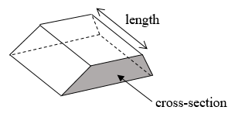Key points

* Volume of a prism = cross-sectional area × length.
* The surface area of a 3D shape is the total area   
  of all its faces.
* 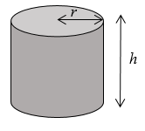Volume of a pyramid =  × area of base × vertical height.
* Volume of a cylinder = *πr*2*h*
* Total surface area of a cylinder = 2*πr*2 + 2*πrh*

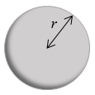

* Volume of a sphere = 
* 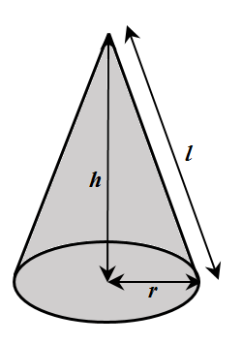Surface area of a sphere = 4*πr*2
* Volume of a cone = 
* Total surface area of a cone = *πrl* + *πr*2

Examples

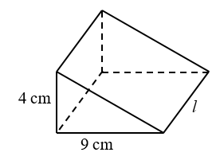**Example 1** The triangular prism has volume 504 cm3.   
 Work out its length.

|  |  |
| --- | --- |
| *V* = *bhl*  504 =  × 9 × 4 × *l*  504 = 18 × *l*  *l* = 504 ÷ 18  = 28 cm | **1** Write out the formula for the volume of a triangular prism.  **2** Substitute known values into the formula.  **3** Simplify  **4** Rearrange to work out *l*.  **5** Remember the units. |

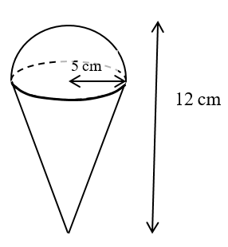**Example 2** Calculate the volume of the 3D solid.  
 Give your answer in terms of *π*.

|  |  |
| --- | --- |
| Total volume = volume of hemisphere  + Volume of cone  =  of *πr*3 + *πr*2*h*  Total volume =  ×  × *π ×* 53  +  × *π ×* 52 × 7  = *π*cm3 | **1** The solid is made up of a hemisphere radius 5 cm and  a cone with radius 5 cm and height 12 − 5 = 7 cm.  **2** Substitute the measurements into the formula for the total volume.  **3** Remember the units. |

Practice

**1** Work out the volume of each solid.  
 Leave your answers in terms of *π* where appropriate.

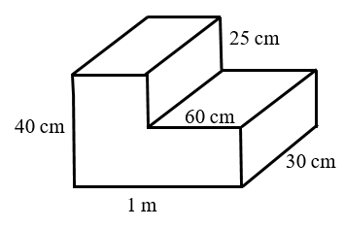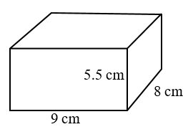 **a b**

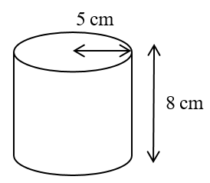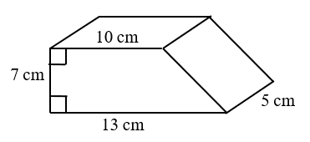 **c d**

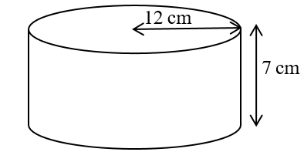 **e** **f**  a sphere with radius 7 cm

**g** a sphere with diameter 9 cm **h** a hemisphere with radius 3 cm

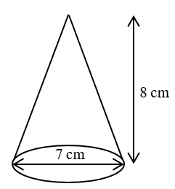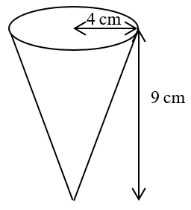 **i**  **j**

**2** A cuboid has width 9.5 cm, height 8 cm and volume 1292 cm3.  
 Work out its length.

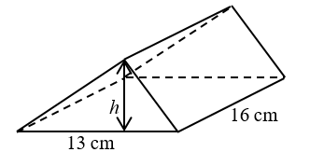**3** The triangular prism has volume 1768 cm3.  
 Work out its height.

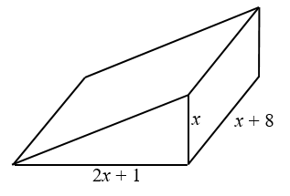Extend

**4** The diagram shows a solid triangular prism.

All the measurements are in centimetres.

The volume of the prism is *V*cm3.

Find a formula for *V* in terms of *x*.

Give your answer in simplified form.

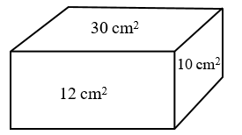**5** The diagram shows the area of each of three   
 faces of a cuboid.

The length of each edge of the cuboid is a whole   
 number of centimetres.

Work out the volume of the cuboid.

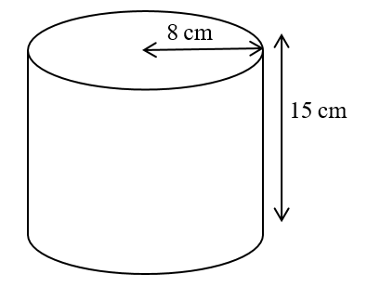**6** The diagram shows a large catering size tin of beans   
 in the shape of a cylinder.

The tin has a radius of 8 cm and a height of 15 cm.

A company wants to make a new size of tin.

The new tin will have a radius of 6.7 cm.

It will have the same volume as the large tin.

Calculate the height of the new tin.

Give your answer correct to one decimal place.

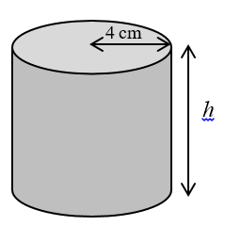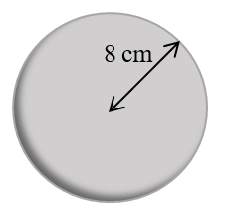**7** The diagram shows a sphere and a solid cylinder.

The sphere has radius 8 cm.

The solid cylinder has a base radius of 4 cm and   
 a height of *h*cm.

The total surface area of the cylinder is half the   
 total surface area of the sphere.

Work out the ratio of the volume of the sphere to  
 the volume of the cylinder.

Give your answer in its simplest form.

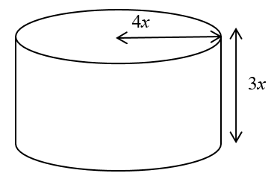**8** The diagram shows a solid metal cylinder.

The cylinder has base radius 4*x* and height 3*x*.

The cylinder is melted down and made into   
 a sphere of radius *r*.

Find an expression for *r* in terms of *x*.

Answers

**1 a** *V* = 396 cm3 **b** *V* = 75 000 cm3

**c** *V* = 402.5 cm3 **d** *V* = 200*π*cm3

**e** *V* = 1008*π* cm3 **f** *V=* *π*  cm3

**g** *V* = 121.5*π* cm3 **h** *V* = 18*π*cm3

**i** *V* = 48*π*cm3 **j** *V* = *π*cm3

**2** 17 cm

**3** 17 cm

**4** *V* = *x*3 + *x*2 + 4*x*

**5** 60 cm3

**6** 21.4 cm

**7** 32 : 9

**8** 