**Trigonometry in right-angled triangles**

**A LEVEL LINKS**

**Scheme of work:** 4a. Trigonometric ratios and graphs

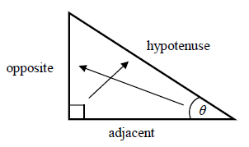Key points

* In a right-angled triangle:
* the side opposite the right angle is called the hypotenuse
* the side opposite the angle *θ* is called the opposite
* the side next to the angle *θ* is called the adjacent.
* In a right-angled triangle:
  + the ratio of the opposite side to the hypotenuse is the sine of angle *θ*, 
  + the ratio of the adjacent side to the hypotenuse is the cosine of angle *θ*, 
  + the ratio of the opposite side to the adjacent side is the tangent of angle *θ*, 
* If the lengths of two sides of a right-angled triangle are given, you can find a missing angle using the inverse trigonometric functions: sin−1, cos−1, tan−1.
* The sine, cosine and tangent of some angles may be written exactly.

|  |  |  |  |  |  |
| --- | --- | --- | --- | --- | --- |
|  | **0** | **30°** | **45°** | **60°** | **90°** |
| **sin** | 0 |  |  |  | 1 |
| **cos** | 1 |  |  |  | 0 |
| **tan** | 0 |  | 1 |  |  |

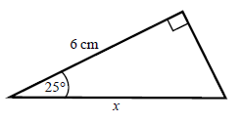Examples

**Example 1** Calculate the length of side *x*.  
 Give your answer correct to 3 significant figures.

|  |  |
| --- | --- |
| *x* = 6.620 267 5...  *x* = 6.62 cm | **1** Always start by labelling the sides.  **2** You are given the adjacent and the hypotenuse so use the cosine ratio.  **3** Substitute the sides and angle into the cosine ratio.  **4** Rearrange to make *x* the subject.  **5** Use your calculator to work out  6 ÷ cos 25°.  **6** Round your answer to 3 significant figures and write the units in your answer. |

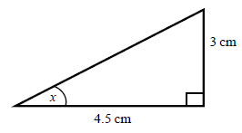

**Example 2** Calculate the size of angle *x*.  
 Give your answer correct to 3 significant figures.

|  |  |
| --- | --- |
| *x* = tan–1  *x* = 33.690 067 5...  *x* = 33.7° | **1** Always start by labelling the sides.  **2** You are given the opposite and the adjacent so use the tangent ratio.  **3** Substitute the sides and angle into the tangent ratio.  **4** Use tan−1 to find the angle.  **5** Use your calculator to work out  tan–1(3 ÷ 4.5).  **6** Round your answer to 3 significant figures and write the units in your answer. |

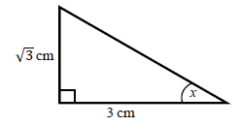**Example 3** Calculate the exact size of angle *x*.

|  |  |
| --- | --- |
| *x* = 30° | **1** Always start by labelling the sides.  **2** You are given the opposite and the adjacent so use the tangent ratio.  **3** Substitute the sides and angle into the tangent ratio.  **4** Use the table from the key points to find the angle. |

Practice

**1** Calculate the length of the unknown side in each triangle.  
 Give your answers correct to 3 significant figures.

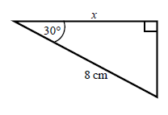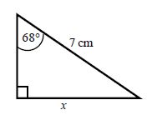 **a b**

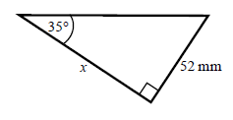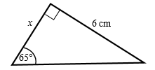 **c d**

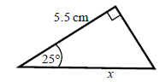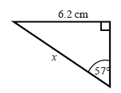 **e f**

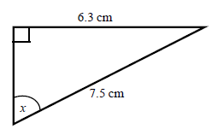**2** Calculate the size of angle *x* in each triangle.  
 Give your answers correct to 1 decimal place.

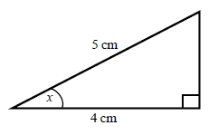 **a b**

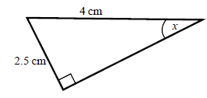

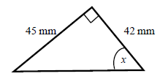 **c d**

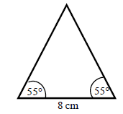**3** Work out the height of the isosceles triangle.  
 Give your answer correct to 3 significant figures.

**Hint:**

Split the triangle into two right-angled triangles.

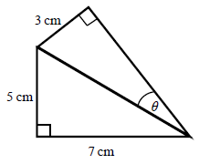**4** Calculate the size of angle *θ*.  
 Give your answer correct to 1 decimal place.

**Hint:**

First work out the length of the common side to both triangles, leaving your answer in surd form.

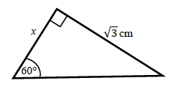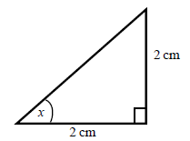**5** Find the exact value of *x* in each triangle.

**a b**

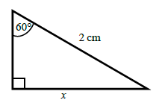

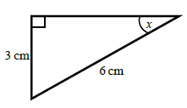 **c d**

**The cosine rule**

**A LEVEL LINKS**

**Scheme of work:** 4a. Trigonometric ratios and graphs

**Textbook:**Pure Year 1, 9.1 The cosine rule

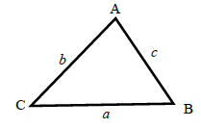Key points

* *a* is the side opposite angle A.

*b* is the side opposite angle B.

*c* is the side opposite angle C.

* You can use the cosine rule to find the length of a side when two sides and the included angle are given.
* To calculate an unknown side use the formula .
* Alternatively, you can use the cosine rule to find an unknown angle if the lengths of all three sides are given.
* To calculate an unknown angle use the formula .

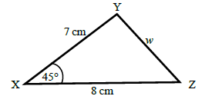Examples

**Example 4** Work out the length of side *w*.  
 Give your answer correct to 3 significant figures.

|  |  |
| --- | --- |
| *w*2 = 33.804 040 51...  *w* =  *w* = 5.81 cm | **1** Always start by labelling the angles and sides.  **2** Write the cosine rule to find the side.  **3** Substitute the values *a*, *b* and *A* into the formula.  **4** Use a calculator to find *w*2 and  then *w*.  **5** Round your final answer to 3 significant figures and write the units in your answer. |

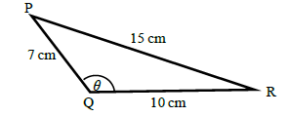**Example 5** Work out the size of angle *θ*.  
 Give your answer correct to 1 decimal place.

|  |  |
| --- | --- |
| *θ* = 122.878 349...  *θ* = 122.9° | **1** Always start by labelling the angles and sides.  **2** Write the cosine rule to find the angle.  **3** Substitute the values *a*, *b* and *c* into the formula.  **4** Use cos−1 to find the angle.  **5** Use your calculator to work out  cos–1(–76 ÷ 140).  **6** Round your answer to 1 decimal place and write the units in your answer. |

Practice

**6** Work out the length of the unknown side in each triangle.  
 Give your answers correct to 3 significant figures.

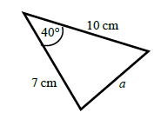 **a b**

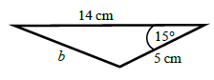

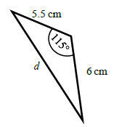

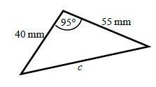 **c d**

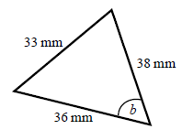**7** Calculate the angles labelled *θ* in each triangle.  
 Give your answer correct to 1 decimal place.

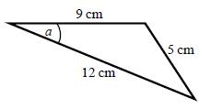 **a b**

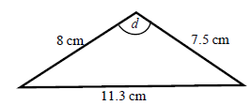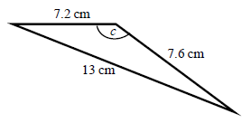 **c d**

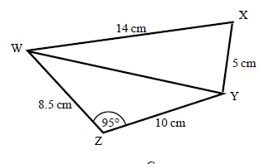**8 a** Work out the length of WY.  
 Give your answer correct to   
 3 significant figures.

**b** Work out the size of angle WXY.  
 Give your answer correct to   
 1 decimal place.

**The sine rule**

**A LEVEL LINKS**

**Scheme of work:** 4a. Trigonometric ratios and graphs

**Textbook:**Pure Year 1, 9.2 The sine rule

Key points

* *a* is the side opposite angle A.  
  *b* is the side opposite angle B.  
  *c* is the side opposite angle C.
* You can use the sine rule to find the length of a side when its opposite angle and another opposite side and angle are given.
* To calculate an unknown side use the formula .
* Alternatively, you can use the sine rule to find an unknown angle if the opposite side and another opposite side and angle are given.
* To calculate an unknown angle use the formula .

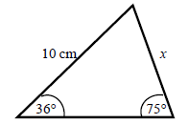Examples

**Example 6** Work out the length of side *x*.  
 Give your answer correct to 3 significant figures.

|  |  |
| --- | --- |
| *x* = 6.09 cm | **1** Always start by labelling the angles and sides.  **2** Write the sine rule to find the side.  **3** Substitute the values *a*, *b*, *A* and *B* into the formula.  **4** Rearrange to make *x* the subject.  **5** Round your answer to 3 significant figures and write the units in your answer. |

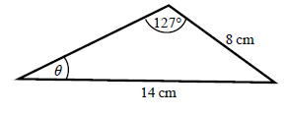**Example 7** Work out the size of angle *θ*.  
 Give your answer correct to 1 decimal place.

|  |  |
| --- | --- |
| *θ* = 27.2° | **1** Always start by labelling the angles and sides.  **2** Write the sine rule to find the angle.  **3** Substitute the values *a*, *b*, *A* and *B* into the formula.  **4** Rearrange to make sin *θ* the subject.  **5** Use sin−1 to find the angle. Round your answer to 1 decimal place and write the units in your answer. |

Practice

**9** Find the length of the unknown side in each triangle.  
 Give your answers correct to 3 significant figures.

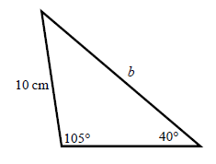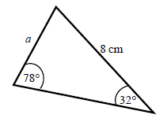

**a b**

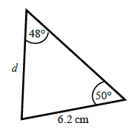

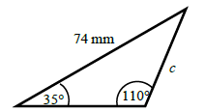 **c d**

**10** Calculate the angles labelled *θ* in each triangle.  
 Give your answer correct to 1 decimal place.

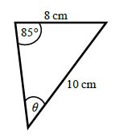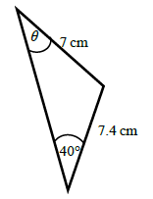

**a b**

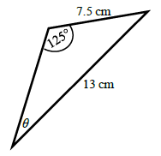

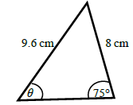 **c d**

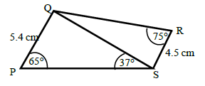**11** **a** Work out the length of QS.  
 Give your answer correct to 3 significant figures.

**b** Work out the size of angle RQS.  
 Give your answer correct to 1 decimal place.

**Areas of triangles**

**A LEVEL LINKS**

**Scheme of work:** 4a. Trigonometric ratios and graphs

**Textbook:**Pure Year 1, 9.3 Areas of triangles

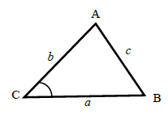Key points

* *a* is the side opposite angle A.  
  *b* is the side opposite angle B.  
  *c* is the side opposite angle C.
* The area of the triangle is .

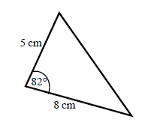Examples

**Example 8** Find the area of the triangle.

|  |  |
| --- | --- |
| Area =  Area =  Area = 19.805 361...  Area = 19.8 cm2 | **1** Always start by labelling the sides and angles of the triangle.  **2** State the formula for the area of a triangle.  **3** Substitute the values of *a*, *b* and *C* into the formula for the area of a triangle.  **4** Use a calculator to find the area.  **5** Round your answer to 3 significant figures and write the units in your answer. |

Practice

**12** Work out the area of each triangle.  
 Give your answers correct to 3 significant figures.

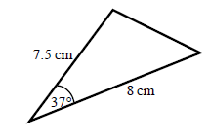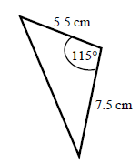 **a b**

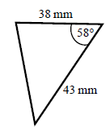 **c**

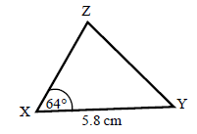

**13** The area of triangle XYZ is 13.3 cm2.  
 Work out the length of XZ.

**Hint:**

Rearrange the formula to make a side the subject.

Extend

**Hint:**

For each one, decide whether to use the cosine or sine rule.

**14** Find the size of each lettered angle or side.  
 Give your answers correct to 3 significant figures.

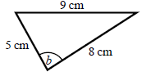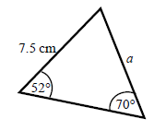 **a b**

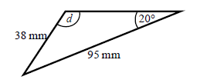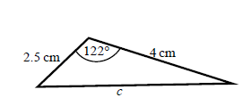 **c d**

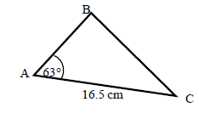**15** The area of triangle ABC is 86.7 cm2.  
 Work out the length of BC.  
 Give your answer correct to 3 significant figures.

Answers

**1 a** 6.49 cm **b** 6.93 cm **c** 2.80 cm   
 **d** 74.3 mm **e** 7.39 cm **f** 6.07 cm

**2 a** 36.9° **b** 57.1° **c** 47.0° **d** 38.7°

**3** 5.71 cm

**4** 20.4°

**5 a** 45° **b** 1 cm **c** 30° **d**  cm

**6 a** 6.46 cm **b** 9.26 cm **c** 70.8 mm **d** 9.70 cm

**7 a** 22.2° **b** 52.9° **c** 122.9° **d** 93.6°

**8 a** 13.7 cm **b** 76.0°

**9 a** 4.33 cm **b** 15.0 cm **c** 45.2 mm **d** 6.39 cm

**10 a** 42.8° **b** 52.8° **c** 53.6° **d** 28.2°

**11 a** 8.13 cm **b** 32.3°

**12 a** 18.1 cm2 **b** 18.7 cm2 **c** 693 mm2

**13** 5.10 cm

**14 a** 6.29 cm **b** 84.3° **c** 5.73 cm **d** 58.8°

**15** 15.3 cm