Circle theorems

A LEVEL LINKS
Scheme of work: 2b. Circles – equation of a circle, geometric problems on a grid

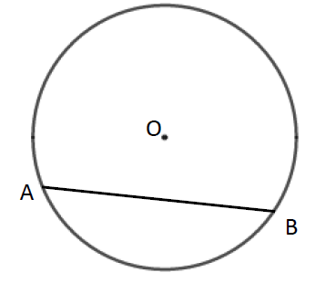
Key points
- A chord is a straight line joining two points on the circumference of a circle.
So AB is a chord.

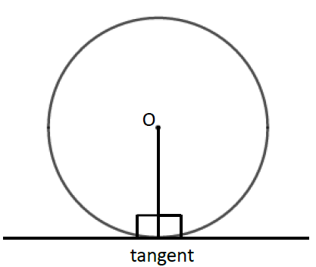

- A tangent is a straight line that touches the circumference of a circle at only one point.
The angle between a tangent and the radius is 90°.

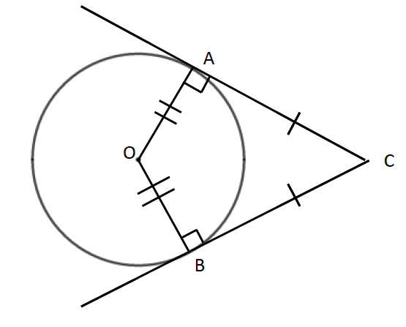

- Two tangents on a circle that meet at a point outside the circle are equal in length.
So AC = BC.

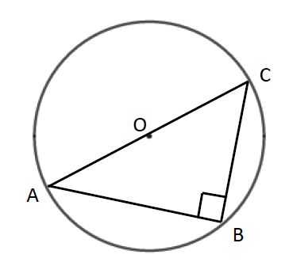

- The angle in a semicircle is a right angle.
So angle ABC = 90°.

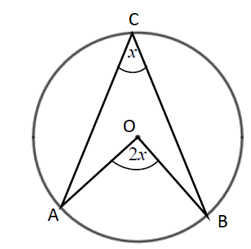

- When two angles are subtended by the same arc, the angle at the centre of a circle is twice the angle at the circumference.
So angle AOB = 2 × angle ACB.
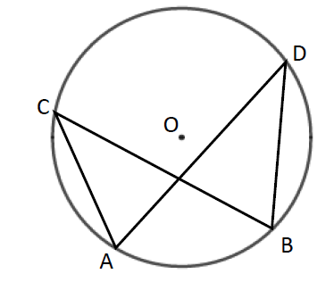
- Angles subtended by the same arc at the circumference are equal. This means that angles in the same segment are equal.
So angle ACB = angle ADB and
angle CAD = angle CBD.

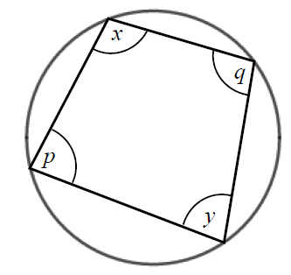

- A cyclic quadrilateral is a quadrilateral with all four vertices on the circumference of a circle.
Opposite angles in a cyclic quadrilateral total 180°.
So x + y = 180° and p + q = 180°.

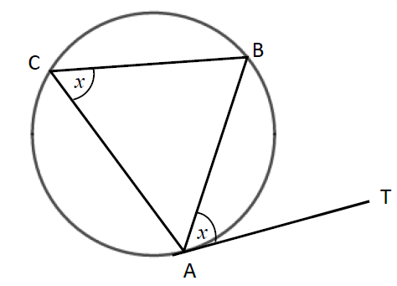

- The angle between a tangent and chord is equal to the angle in the alternate segment, this is known as the alternate segment theorem.
So angle BAT = angle ACB.

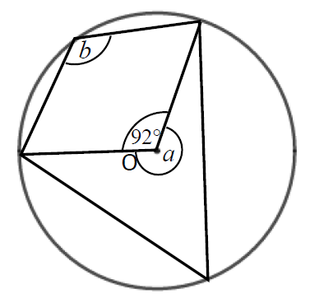
Examples
Example 1 Work out the size of each angle
marked with a letter.
Give reasons for your answers.

Angle a = 360° − 92°  = 268°  as the angles in a full turn total 360°.  Angle b = 268° ÷ 2  = 134°  as when two angles are subtended by the same arc, the angle at the centre of a circle is twice the angle at the circumference. | 1 The angles in a full turn total 360°.  2 Angles a and b are subtended by  the same arc, so angle b is half of angle a.

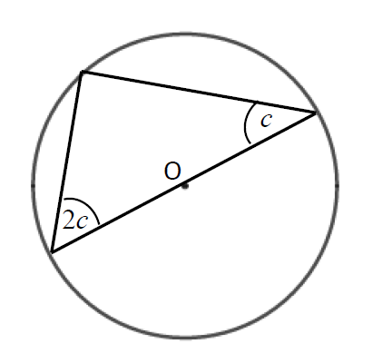
Example 2 Work out the size of the angles in the triangle.
Give reasons for your answers.

Angles are 90°, 2c and c.  90° + 2c + c = 180°  90° + 3c = 180°  3c = 90°  c = 30°  2c = 60°  The angles are 30°, 60° and 90° as the angle in a semi-circle is a right angle and the angles in a triangle total 180°. | 1 The angle in a semicircle is a right angle.  2 Angles in a triangle total 180°.  3 Simplify and solve the equation.
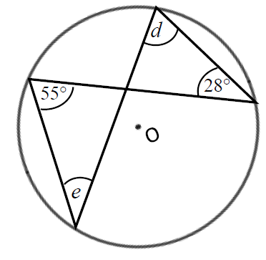
Example 3 Work out the size of each angle marked with a letter.
Give reasons for your answers.

Angle d = 55° as angles subtended by the same arc are equal.  Angle e = 28° as angles subtended by the same arc are equal. | 1 Angles subtended by the same arc are equal so angle 55° and angle d are equal.  2 Angles subtended by the same arc are equal so angle 28° and angle e are equal.
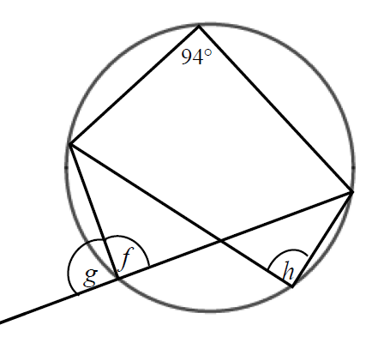
Example 4 Work out the size of each angle marked with a letter.
Give reasons for your answers.

Angle f = 180° − 94°  = 86°  as opposite angles in a cyclic quadrilateral total 180°. | 1 Opposite angles in a cyclic quadrilateral total 180° so angle 94° and angle f total 180°.  (continued on next page)
Angle g = 180° − 86°  = 84°  as angles on a straight line total 180°.  Angle h = angle f = 86° as angles subtended by the same arc are equal. | 2 Angles on a straight line total 180° so angle f and angle g total 180°.  3 Angles subtended by the same arc are equal so angle f and angle h are equal.
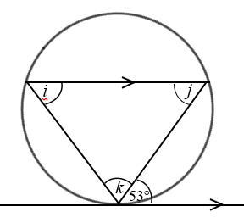
Example 5 Work out the size of each angle marked with a letter.
Give reasons for your answers.

Angle i = 53° because of the alternate segment theorem.  Angle j = 53° because it is the alternate angle to 53°.  Angle k = 180° − 53° − 53°  = 74°  as angles in a triangle total 180°. | 1 The angle between a tangent and chord is equal to the angle in the alternate segment.  2 As there are two parallel lines, angle 53° is equal to angle j because they are alternate angles.  3 The angles in a triangle total 180°, so i + j + k = 180°.
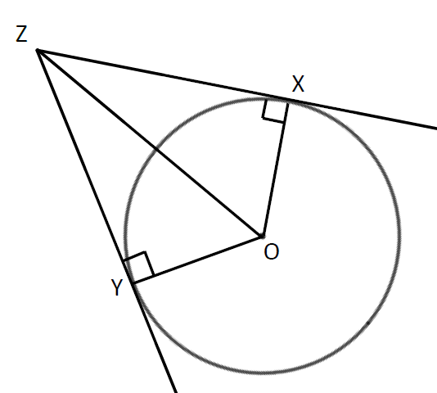
Example 6 XZ and YZ are two tangents to a circle with centre O.
Prove that triangles XZO and YZO are congruent.

Angle OXZ = 90° and angle OYZ = 90° as the angles in a semicircle are right angles.  OZ is a common line and is the hypotenuse in both triangles.  OX = OY as they are radii of the same circle.  So triangles XZO and YZO are congruent, RHS. | For two triangles to be congruent you need to show one of the following.  - All three corresponding sides are equal (SSS).  - Two corresponding sides and the included angle are equal (SAS).  - One side and two corresponding angles are equal (ASA).  - A right angle, hypotenuse and a shorter side are equal (RHS).

Practice
1 Work out the size of each angle marked with a letter.
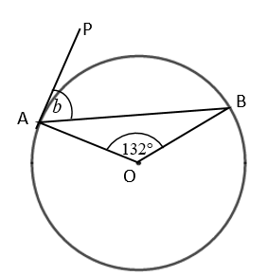
Give reasons for your answers.
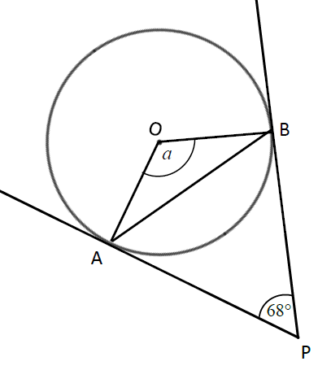
a b

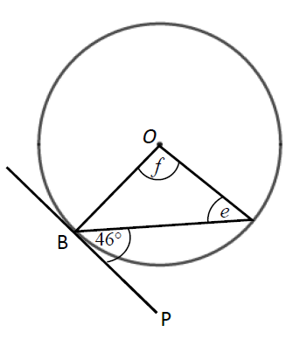
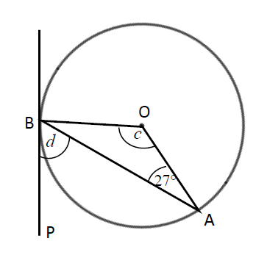

c d

A

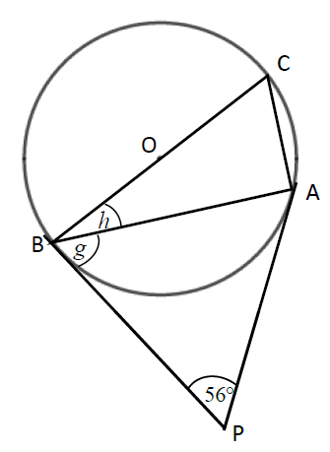
e

2 Work out the size of each angle marked with a letter.
Give reasons for your answers.
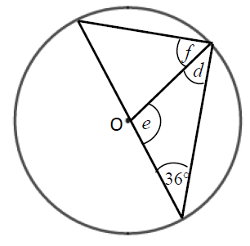
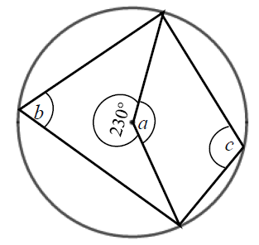
a b

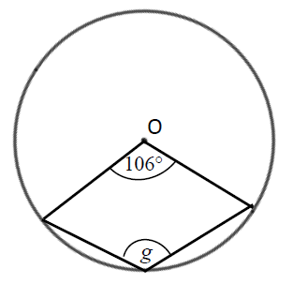
c
Hint
The reflex angle at point O and angle g are subtended by the same arc. So the reflex angle is twice the size of angle g.

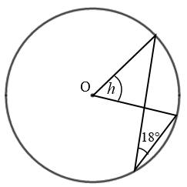
d
Hint
Angle 18° and angle h are subtended by the same arc.

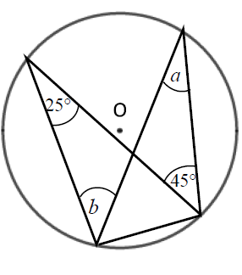
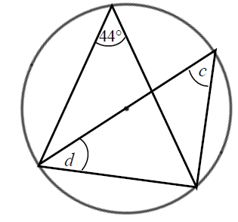
3 Work out the size of each angle marked with a letter.
Give reasons for your answers.
a b
Hint
One of the angles is in a semicircle.

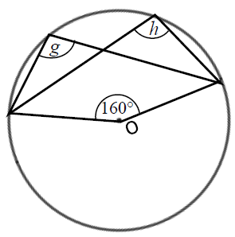
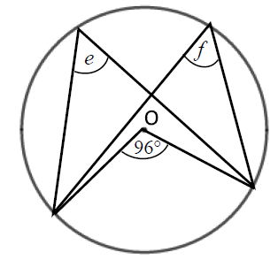
c d

4 Work out the size of each angle marked with a letter.
Give reasons for your answers.
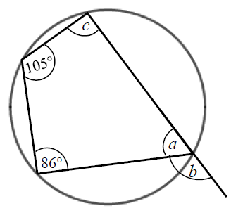
a
Hint
An exterior angle of a cyclic quadrilateral is equal to the opposite interior angle.

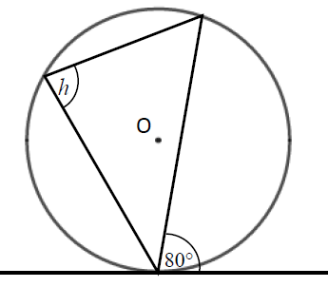
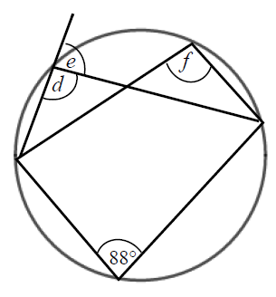
b c

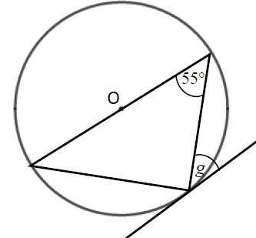
d
Hint
One of the angles is in a semicircle.

Extend
5 Prove the alternate segment theorem.

Answers
1 a a = 112°, angle OAP = angle OBP = 90° and angles in a quadrilateral total 360°.
b b = 66°, triangle OAB is isosceles, Angle OAP = 90° as AP is tangent to the circle.
c c = 126°, triangle OAB is isosceles.
d = 63°, Angle OBP = 90° as BP is tangent to the circle.
d e = 44°, the triangle is isosceles, so angles e and angle OBA are equal. The angle OBP = 90° as BP is tangent to the circle.
f = 92°, the triangle is isosceles.
e g = 62°, triangle ABP is isosceles as AP and BP are both tangents to the circle.
h = 28°, the angle OBP = 90°.
2 a a = 130°, angles in a full turn total 360°.
b = 65°, the angle at the centre of a circle is twice the angle at the circumference.
c = 115°, opposite angles in a cyclic quadrilateral total 180°.
b d = 36°, isosceles triangle.
e = 108°, angles in a triangle total 180°.
f = 54°, angle in a semicircle is 90°.
c g = 127°, angles at a full turn total 360°, the angle at the centre of a circle is twice the angle at the circumference.
d h = 36°, the angle at the centre of a circle is twice the angle at the circumference.
3 a a = 25°, angles in the same segment are equal.
b = 45°, angles in the same segment are equal.
b c = 44°, angles in the same segment are equal.
d = 46°, the angle in a semicircle is 90° and the angles in a triangle total 180°.
c e = 48°, the angle at the centre of a circle is twice the angle at the circumference.
f = 48°, angles in the same segment are equal.
d g = 100°, angles at a full turn total 360°, the angle at the centre of a circle is twice the angle at the circumference.
h = 100°, angles in the same segment are equal.
4 a a = 75°, opposite angles in a cyclic quadrilateral total 180°.
b = 105°, angles on a straight line total 180°.
c = 94°, opposite angles in a cyclic quadrilateral total 180°.
b d = 92°, opposite angles in a cyclic quadrilateral total 180°.
e = 88°, angles on a straight line total 180°.
f = 92°, angles in the same segment are equal.
c h = 80°, alternate segment theorem.
d g = 35°, alternate segment theorem and the angle in a semicircle is 90°.

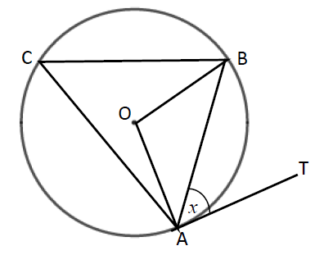
5 Angle BAT = x.
Angle OAB = 90° − x because the angle between the tangent and the radius is 90°.
OA = OB because radii are equal.
Angle OAB = angle OBA because the base of isosceles triangles are equal.
Angle AOB = 180° − (90° − x) − (90° − x) = 2x because angles in a triangle total 180°.
Angle ACB = 2x ÷ 2 = x because the angle at the centre is twice the angle at the circumference.

