**Proportion**

**A LEVEL LINKS**

**Scheme of work:** 2a. Straight-line graphs, parallel/perpendicular, length and area problems

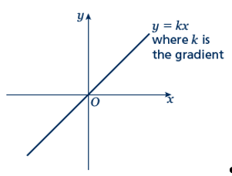Key points

* Two quantities are in direct proportion when, as one quantity increases, the other increases at the same rate.  
  Their ratio remains the same.
* ‘*y* is directly proportional to *x*’ is written as *y*  *x*.  
  If *y*  *x* then *y* = *kx*, where *k* is a constant.
* When *x* is directly proportional to *y*, the graph is a straight line passing through the origin.

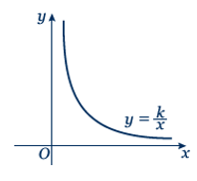

* Two quantities are in inverse proportion when, as one quantity increases, the other decreases at the same rate.
* ‘*y* is inversely proportional to *x*’ is written as *y*  .   
  If *y*   then *y* = , where *k* is a constant.
* When *x* is inversely proportional to *y* the graph is the same shape as the graph of *y* = 

Examples

**Example 1** *y* is directly proportional to *x*.  
When *y* = 16, *x* = 5.  
**a** Find *x* when *y* = 30.  
**b** Sketch the graph of the formula.

|  |  |
| --- | --- |
| **a**  *y* = *kx*  16 = *k* × 5  *k* = 3.2  *y* = 3.2*x*  When *y* = 30,  30 = 3.2 × *x*  *x* = 9.375 | **1** Write *y* is directly proportional to *x*, using the symbol .  **2** Write the equation using *k*.  **3** Substitute *y* = 16 and *x* = 5 into  *y* = *kx*.  **4** Solve the equation to find *k*.  **5** Substitute the value of *k* back into the equation *y* = *kx*.  **6** Substitute *y* = 30 into *y* = 3.2*x* and solve to find *x* when *y* = 30. |

|  |  |
| --- | --- |
| **b** | **7** The graph of *y* = 3.2*x* is a straight line passing through (0, 0) with a gradient of 3.2. |

**Example 2** *y* is directly proportional to *x*2.  
When *x* = 3, *y* = 45.  
**a** Find *y* when *x* = 5.  
**b** Find *x* when *y* = 20.

|  |  |
| --- | --- |
| **a**  *y* = *kx*2  45 = *k* × 32  *k* = 5  *y* = 5*x*2  When *x* = 5,  *y* = 5 × 52  *y* = 125  **b** 20 = 5 × *x*2  *x*2 = 4  *x* = ±2 | **1** Write *y* is directly proportional to *x*2, using the symbol .  **2** Write the equation using *k*.  **3** Substitute *y* = 45 and *x* = 3 into  *y* = *kx*2.  **4** Solve the equation to find *k*.  **5** Substitute the value of *k* back into the equation *y* = *kx*2.  **6** Substitute *x* = 5 into *y* = 5*x*2 and solve to find *y* when *x* = 5.  **7** Substitute *y* = 20 into *y* = 5*x*2 and solve to find *x* when *y* = 4. |

**Example 3** *P* is inversely proportional to *Q*.  
When *P* = 100, *Q* = 10.  
Find *Q* when *P* = 20.

|  |  |
| --- | --- |
| *k* = 1000 | **1** Write *P* is inversely proportional  to *Q*, using the symbol .  **2** Write the equation using *k*.  **3** Substitute *P* = 100 and *Q* = 10.    **4** Solve the equation to find *k*.  **5** Substitute the value of *k* into  **6** Substitute *P* = 20 into  and solve to find *Q* when *P* = 20. |

Practice

**Hint**

Substitute the values given for *P* and *h* into the formula to calculate *k*.

**1** Paul gets paid an hourly rate. The amount of pay (£*P*) is directly proportional to the number of hours (*h*) he works.   
When he works 8 hours he is paid £56.  
If Paul works for 11 hours, how much is he paid?

**2** *x* is directly proportional to *y*. *x* = 35 when *y* = 5.

**a** Find a formula for *x* in terms of *y*.

**b** Sketch the graph of the formula.

**c** Find *x* when *y* = 13.

**d** Find *y* when *x* = 63.

**3** *Q* is directly proportional to the square of *Z*.   
 *Q* = 48 when *Z* = 4.

**a** Find a formula for *Q* in terms of *Z*.

**b** Sketch the graph of the formula.

**c** Find *Q* when *Z* = 5.

**d** Find *Z* when *Q* = 300.

**4** *y* is directly proportional to the square of *x*.  
 *x* = 2 when *y* = 10.

**a** Find a formula for *y* in terms of *x*.

**b** Sketch the graph of the formula.

**c** Find *x* when *y* = 90.

**5** *B* is directly proportional to the square root of *C.   
 C* = 25 when *B* = 10.

**a** Find *B* when *C* = 64.

**b** Find *C* when *B* = 20.

**6** *C* is directly proportional to *D*.  
 *C* = 100 when *D* = 150.  
 Find *C* when *D* = 450.

**7** *y* is directly proportional to *x*.  
 *x* = 27 when *y* = 9.  
 Find *x* when *y* = 3.7.

**8** *m* is proportional to the cube of *n*.  
 *m* = 54 when *n* = 3.  
 Find *n* when *m* = 250.

Extend

**9** *s* is inversely proportional to *t*.

**a** Given that *s* = 2 when *t* = 2, find a formula for *s* in terms of *t*.

**b** Sketch the graph of the formula.

**c** Find *t* when *s* = 1.

**10** *a* is inversely proportional to *b*.  
*a* = 5 when *b* = 20.

**a** Find *a* when *b* = 50.

**b** Find *b* when *a* = 10.

**11** *v* is inversely proportional to *w*.  
*w* = 4 when *v* = 20.

**a** Find a formula for *v* in terms of *w*.

**b** Sketch the graph of the formula.

**c** Find *w* when *v* = 2.

**12** *L* is inversely proportional to *W*.   
*L* = 12 when *W* = 3.  
Find *W* when *L* = 6.

**13** *s* is inversely proportional to *t*.  
*s* = 6 when *t* = 12.

**a** Find *s* when *t* = 3.

**b** Find *t* when *s* = 18.

**14** *y* is inversely proportional to *x*2.  
*y* = 4 when *x* = 2.  
Find *y* when *x* = 4.

**15** *y* is inversely proportional to the square root of *x*.  
*x* = 25 when *y* = 1.  
Find *x* when *y* = 5.

**16** *a* is inversely proportional to *b*.  
*a* = 0.05 when *b* = 4.

**a** Find *a* when *b* = 2.

**b** Find *b* when *a* = 2.

Answers

**1** £77

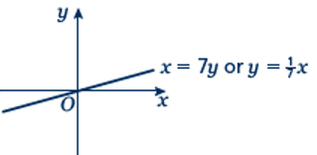**2 a** *x* = 7*y* **b**

**c** 91 **d** 9

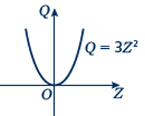**3 a** *Q* = 3*Z*2 **b**

**c** 75 **d** ±10

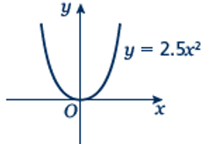**4 a** *y* = 2.5*x*2 **b**

**c** ±6

**5 a** 16 **b** 100

**6** 300

**7** 11.1

**8** 5

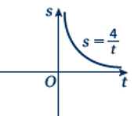**9 a** **  **b**

**c** 4

**10 a** 2 **b** 10

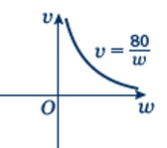**11 a** ** **b**

**c** 40

**12** 6

**13 a** 24 **b** 4

**14** 1

**15** 1

**16 a** 0.1 **b** 0.1