**Pythagoras’ theorem**

**A LEVEL LINKS**

**Scheme of work:** 2a. Straight-line graphs, parallel/perpendicular, length and area problems

Key points

* 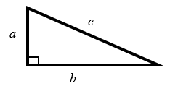In a right-angled triangle the longest side is called the hypotenuse.
* Pythagoras’ theorem states that for a right-angled triangle the square of the hypotenuse is equal to the sum of the squares of the other two sides.  
  *c*2 = *a*2 + *b*2

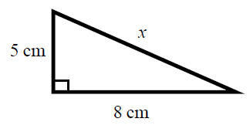Examples

**Example 1** Calculate the length of the hypotenuse.  
Give your answer to 3 significant figures.

|  |  |
| --- | --- |
| *c*2 = *a*2 + *b*2    *x*2 = 52 + 82  *x*2 = 25 + 64  *x*2 = 89    *x* = 9.433 981 13...  *x* = 9.43 cm | **1** Always start by stating the formula for Pythagoras’ theorem and labelling the hypotenuse *c* and the other two sides *a* and *b*.  **2** Substitute the values of *a*, *b* and *c* into the formula for Pythagoras' theorem.  **3** Use a calculator to find the square root.  **4** Round your answer to 3 significant figures and write the units with your answer. |

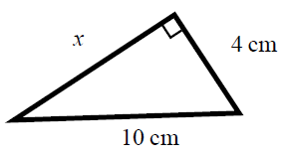**Example 2** Calculate the length *x*.   
Give your answer in surd form.

|  |  |
| --- | --- |
| *c*2 = *a*2 + *b*2  102 = *x*2 + 42  100 = *x*2 + 16  *x*2 = 84    cm | **1** Always start by stating the formula for Pythagoras' theorem.  **2** Substitute the values of *a*, *b* and *c* into the formula for Pythagoras' theorem.  **3** Simplify the surd where possible and write the units in your answer. |

Practice

**1** Work out the length of the unknown side in each triangle.  
 Give your answers correct to 3 significant figures.

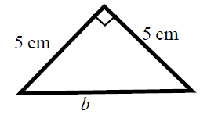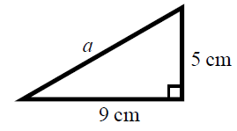 **a b**

**c d**

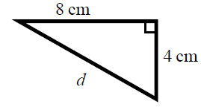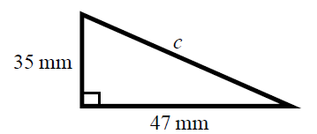

**2** Work out the length of the unknown side in each triangle.  
 Give your answers in surd form.

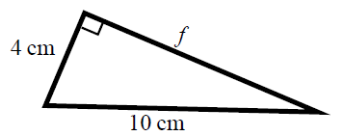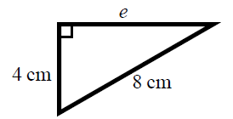 **a b**

**c d**

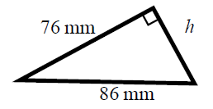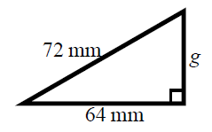

**3** Work out the length of the unknown side in each triangle.   
 Give your answers in surd form.

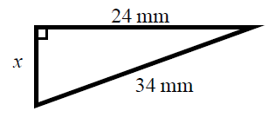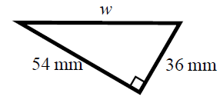 **a b**

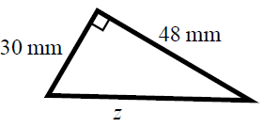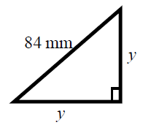 **c d**

**4** A rectangle has length 84 mm and width 45 mm.   
 Calculate the length of the diagonal of the rectangle.  
 Give your answer correct to 3 significant figures.

**Hint**

Draw a sketch of the rectangle.

Extend

**5** A yacht is 40 km due North of a lighthouse.  
A rescue boat is 50 km due East of the same lighthouse.  
Work out the distance between the yacht and the rescue boat.  
Give your answer correct to 3 significant figures.

**Hint**

Draw a diagram using the information given in the question.

**6** Points A and B are shown on the diagram.  
Work out the length of the line AB.   
Give your answer in surd form.

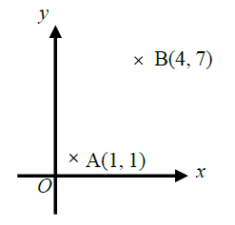

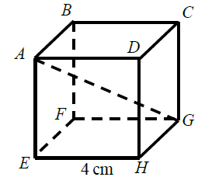**7** A cube has length 4 cm.   
Work out the length of the diagonal *AG*.  
Give your answer in surd form.

Answers

**1 a** 10.3 cm **b** 7.07 cm

**c** 58.6 mm **d** 8.94 cm

**2 a**  cm **b**  cm

**c**  mm **d**  mm

**3 a**  mm **b**  mm

**c**  mm **d**  mm

**4** 95.3 mm

**5** 64.0 km

**6**  units

**7**  cm