**Straight line graphs**

**A LEVEL LINKS**

**Scheme of work:** 2a. Straight-line graphs, parallel/perpendicular, length and area problems

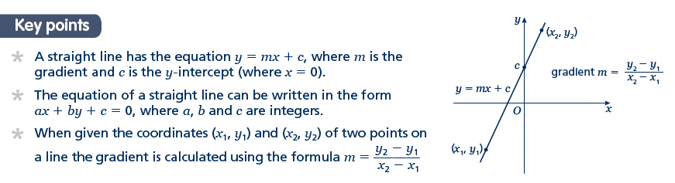Key points

* A straight line has the equation *y* = *mx* + *c*, where *m* is the gradient and *c* is the *y*-intercept (where *x* = 0).
* The equation of a straight line can be written in the form *ax* + *by* + *c* = 0, where *a*, *b* and *c* are integers.
* When given the coordinates (*x*1, *y*1) and (*x*2, *y*2) of two points on a line the gradient is calculated using the formula 

Examples

**Example 1** A straight line has gradient  and *y*-intercept 3.  
Write the equation of the line in the form *ax* + *by* + *c* = 0.

|  |  |
| --- | --- |
| *m* =  and *c* = 3  So *y* = *x* + 3  *x* + *y* – 3 = 0  *x* + 2*y* − 6 = 0 | **1** A straight line has equation *y*= *mx*+ *c*. Substitute the gradient and *y*-intercept given in the question into thisequation.  **2** Rearrange the equation so all the terms are on one side and 0 is on  the other side.  **3** Multiply both sides by 2 to eliminate the denominator. |

**Example 2** Find the gradient and the *y*-intercept of the line with the equation 3*y* − 2*x* + 4 = 0.

|  |  |
| --- | --- |
| 3*y* − 2*x* + 4 = 0  3*y* = 2*x* − 4    Gradient = *m* =  *y*-intercept = *c* = | **1** Make *y* the subject of the equation.  **2** Divide all the terms by three to get the equation in the form *y* = …  **3** In the form *y* = *mx* + *c*, the gradient is *m* and the *y*-intercept is *c*. |

**Example 3** Find the equation of the line which passes through the point (5, 13) and has gradient 3.

|  |  |
| --- | --- |
| *m* = 3  *y* = 3*x* + *c*  13 = 3 × 5 + *c*  13 = 15 + *c*  *c* = −2  *y* = 3*x* − 2 | **1** Substitute the gradient given in the question into the equation of a straight line *y* = *mx* + *c*.  **2** Substitute the coordinates *x* = 5 and *y* = 13 into the equation.  **3** Simplify and solve the equation.  **4** Substitute *c* = −2 into the equation *y*= 3*x*+ *c* |

**Example 4** Find the equation of the line passing through the points with coordinates (2, 4) and (8, 7).

|  |  |
| --- | --- |
| , ,  and        *c* = 3 | **1** Substitute the coordinates into the equation  to work out the gradient of the line.  **2** Substitute the gradient into the equation of a straight line *y*= *mx*+ *c*.  **3** Substitute the coordinates of either point into the equation.  **4** Simplify and solve the equation.  **5** Substitute *c* = 3 into the equation |

Practice

**1** Find the gradient and the *y*-intercept of the following equations.

**a** *y* = 3*x* + 5 **b** *y* = *x* – 7

**Hint**

Rearrange the equations to the form *y* = *mx* + *c*

**c** 2*y* = 4*x* – 3 **d** *x* + *y* = 5

**e** 2*x* – 3*y* – 7 = 0 **f** 5*x* + *y* – 4 = 0

**2** Copy and complete the table, giving the equation of the line in the form *y* = *mx* + *c*.

|  |  |  |
| --- | --- | --- |
| **Gradient** | ***y*-intercept** | **Equation of the line** |
| 5 | 0 |  |
| –3 | 2 |  |
| 4 | –7 |  |

**3** Find, in the form *ax* + *by* + *c* = 0 where *a*, *b* and *c* are integers, an equation for each of the lines with the following gradients and *y*-intercepts.

**a** gradient , *y*-intercept –7 **b** gradient 2, *y*-intercept 0

**c** gradient , *y*-intercept 4 **d** gradient –1.2, *y*-intercept –2

**4** Write an equation for the line which passes though the point (2, 5) and has gradient 4.

**5** Write an equation for the line which passes through the point (6, 3) and has gradient 

**6** Write an equation for the line passing through each of the following pairs of points.

**a** (4, 5), (10, 17) **b** (0, 6), (–4, 8)

**c** (–1, –7), (5, 23) **d** (3, 10), (4, 7)

Extend

**7** The equation of a line is 2*y* + 3*x* – 6 = 0.  
Write as much information as possible about this line.

Answers

**1** **a** *m* = 3, *c* = 5 **b** *m* = , *c* = –7

**c** *m* = 2, *c* =  **d** *m* = –1, *c* = 5

**e** *m* = , *c* = or –2 **f** *m* = –5, *c* = 4

**2**

|  |  |  |
| --- | --- | --- |
| **Gradient** | ***y*-intercept** | **Equation of the line** |
| 5 | 0 | *y* = 5*x* |
| –3 | 2 | *y* = –3*x* + 2 |
| 4 | –7 | *y* = 4*x* –7 |

**3 a** *x* + 2*y* + 14 = 0 **b** 2*x* – *y* = 0

**c** 2*x* – 3*y* + 12 = 0 **d** 6*x* + 5*y* + 10 = 0

**4** *y* = 4*x* – 3

**5** *y* = *x* + 7

**6 a** *y* = 2*x* – 3 **b** *y* = *x* + 6

**c** *y* = 5*x* –2 **d** *y* = –3*x* + 19

**7** , the gradient is  and the *y*-intercept is 3.  
The line intercepts the axes at (0, 3) and (2, 0).  
Students may sketch the line or give coordinates that lie on the line such as  or .