Solving simultaneous equations graphically

A LEVEL LINKS
Scheme of work: 1c. Equations – quadratic/linear simultaneous

Key points
- You can solve any pair of simultaneous equations by drawing the graph of both equations and finding the point/points of intersection.
Examples
Example 1 Solve the simultaneous equations y = 5x + 2 and x + y = 5 graphically.
y = 5 – x  y = 5 – x has gradient –1 and y-intercept 5.  y = 5x + 2 has gradient 5 and y-intercept 2.  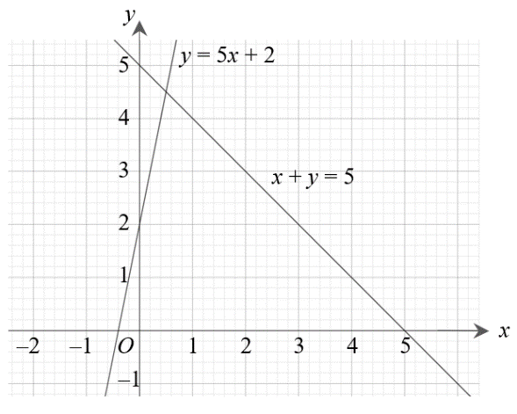  Lines intersect at  x = 0.5, y = 4.5  Check:  First equation y = 5x + 2:  4.5 = 5 × 0.5 + 2 YES  Second equation x + y = 5:  0.5 + 4.5 = 5 YES | 1 Rearrange the equation x + y = 5 to make y the subject.  2 Plot both graphs on the same grid using the gradients and  y-intercepts.  3 The solutions of the simultaneous equations are the point of intersection.  4 Check your solutions by substituting the values into both equations.

Example 2 Solve the simultaneous equations y = x − 4 and y = x² − 4x + 2 graphically.
x 0 1 2 3 4  y 2 –1 –2 –1 2  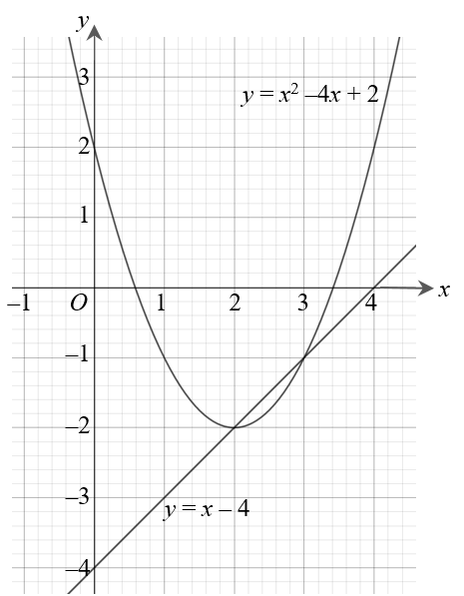  The line and curve intersect at  x = 3, y = −1 and x = 2, y = −2  Check:  First equation y = x − 4:  −1 = 3 − 4 YES  −2 = 2 − 4 YES  Second equation y = x² − 4x + 2:  −1 = 3² − 4 × 3 + 2 YES  −2 = 2² − 4 × 2 + 2 YES | 1 Construct a table of values and calculate the points for the quadratic equation.  2 Plot the graph.  3 Plot the linear graph on the same grid using the gradient and  y-intercept.  y = x – 4 has gradient 1 and  y-intercept –4.  4 The solutions of the simultaneous equations are the points of intersection.  5 Check your solutions by substituting the values into both equations.

Practice
1 Solve these pairs of simultaneous equations graphically.
a y = 3x − 1 and y = x + 3
b y = x − 5 and y = 7 − 5x
c y = 3x + 4 and y = 2 − x
2 Solve these pairs of simultaneous equations graphically.
Hint
Rearrange the equation to make y the subject.
a x + y = 0 and y = 2x + 6
b 4x + 2y = 3 and y = 3x − 1
c 2x + y + 4 = 0 and 2y = 3x − 1
3 Solve these pairs of simultaneous equations graphically.
a y = x − 1 and y = x² − 4x + 3
b y = 1 − 3x and y = x² − 3x − 3
c y = 3 − x and y = x² + 2x + 5
4 Solve the simultaneous equations x + y = 1 and x² + y² = 25 graphically.
Extend
5 a Solve the simultaneous equations 2x + y = 3 and x² + y = 4
i graphically
ii algebraically to 2 decimal places.
b Which method gives the more accurate solutions? Explain your answer.

Answers
1 a x = 2, y = 5
b x = 2, y = −3
c x = −0.5, y = 2.5
2 a x = −2, y = 2
b x = 0.5, y = 0.5
c x = −1, y = −2
3 a x = 1, y = 0 and x = 4, y = 3
b x = −2, y = 7 and x = 2, y = −5
c x = −2, y = 5 and x = −1, y = 4
4 x = −3, y = 4 and x = 4, y = −3
5 a i x = 2.5, y = −2 and x = −0.5, y = 4
ii x = 2.41, y = −1.83 and x = −0.41, y = 3.83
b Solving algebraically gives the more accurate solutions as the solutions from the graph are only estimates, based on the accuracy of your graph.

