Year 12 Pre-Course Homework

Please go to YouTube and type in PHILOSOPHY – Thomas Aquinas and watch the clip.
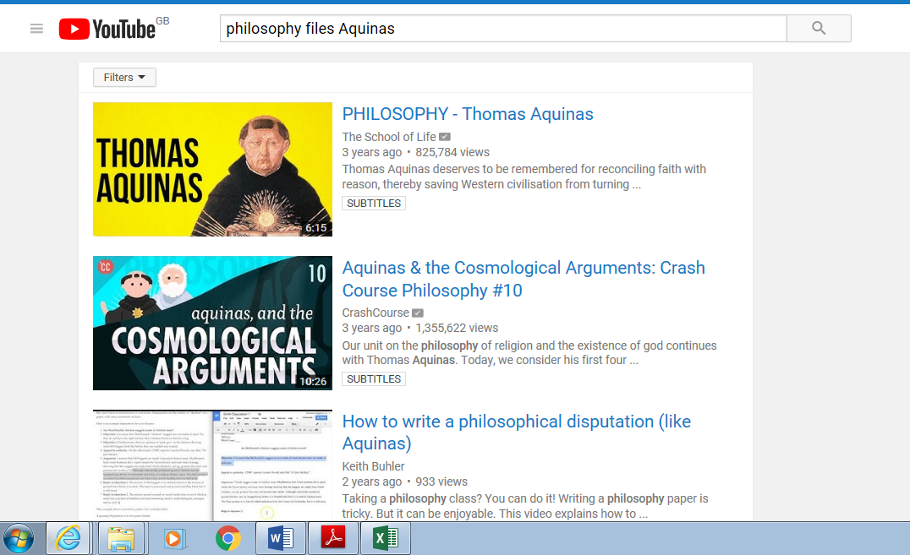

- Who was Thomas Aquinas and in what period of time did he live?

- What is meant by ‘reason’?

- What is the difference between natural law and eternal law? Explain and give examples of both.

- According to Aquinas where can people acquire knowledge?
- How did Aquinas influence Christianity in a positive way?

- What are the names of his two most famous works?

- Find out about and write a summary about two of the ideas Aquinas had which you will study - natural moral law and the cosmological argument.

