# Cambridge Technicals in

# Digital Media

# SUMMER TRANSITION TASK



# Unit 1: Media products and audiences

# LO1: Understand the ownership models of media institutions

**During this task you will conduct some independent research for the first section of this course.**

**Whilst completing this research you must keep a log of all the sources you have used to help you. Make a note of the website URL and the date you accessed it.**

# Ownership structures

Ownership structures are important in understanding how media industries operate in creating products to target an audience.

Your task is to:

* Identity and evaluate key terminology associated with ownership structures.
* Identify the similarities and differences in the ownership of conglomerates compared to independent companies.

**Key terminology questions**

1. What is a conglomerate? Can you think of any examples?
2. What is an independent company? Can you think of any examples?
3. How could independent companies be disadvantaged compared to a conglomerate in regards to ownership?
4. Examples of contemporary cross media conglomerates are shown in the infographic below:

**Figure 1:** *Examples of cross media conglomerates*

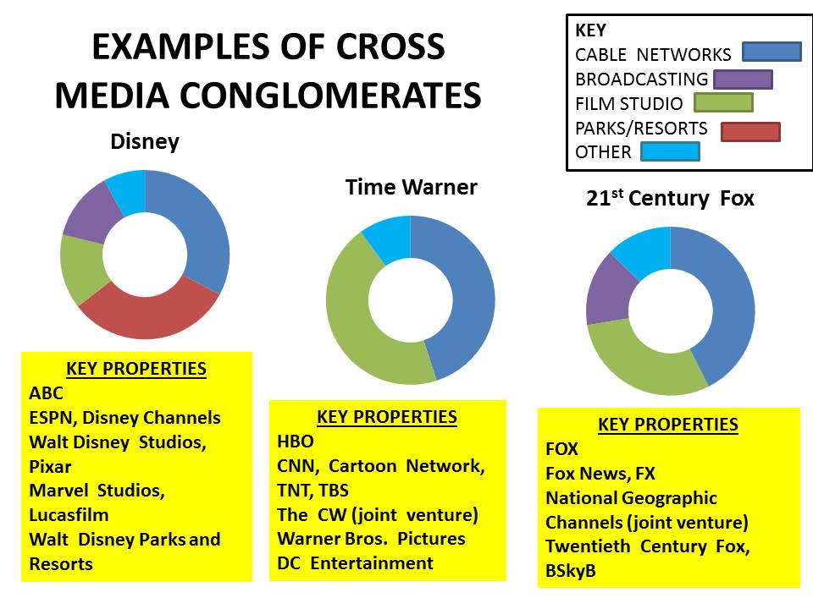

Using the infographic above answer the following:

* 1. What is a cross media company?
  2. What subsidiaries does 21st Century Fox own?
  3. How can this type of ownership impact a conglomerate compared to an independent company?

1. What is the purpose of a company that is described as commercial?
2. The BBC is classed as a public service broadcaster. Using this link: (<https://www.bbc.com/aboutthebbc>), answer the following questions:
3. What is the purpose of a public service broadcaster?
4. What is the mission statement of the BBC?
5. How is the BBC funded?
6. How does the BBC have cross media ownership?
7. What is a joint venture?
8. Vertical integration is where a company can control the production, distribution and consumption of its products. Therefore, how can a conglomerate use this integration, compared to an independent company?
9. Horizontal integration is where a company uses its subsidiaries to cross promote a brand and/or product across different platforms/subsidiaries.

Using Figure 2, what are the opportunities for a company based on horizontal integration?

**Figure 2:** *Horizontal integration of Sony and Skyfall*

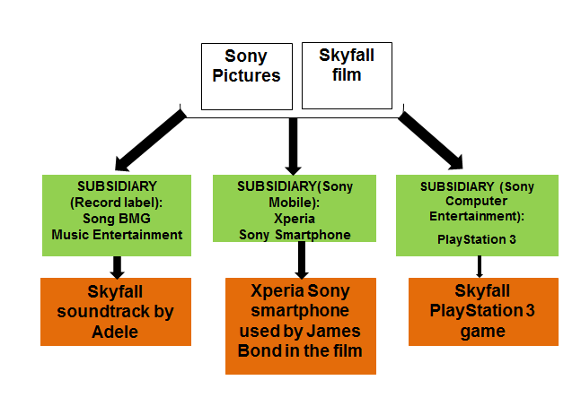

1. The effect of horizontal integration is called synergy which means cross promotion. Provide three more examples of synergy you have seen recently of a brand and/or product.
2. The production process is when a media product is being made and includes pre-production, production and post-production.
3. Define what pre-production, production and post-production mean.
4. Using the mind map diagram below, state what would happen in each of the pre-production, production and post-production processes for a video game.

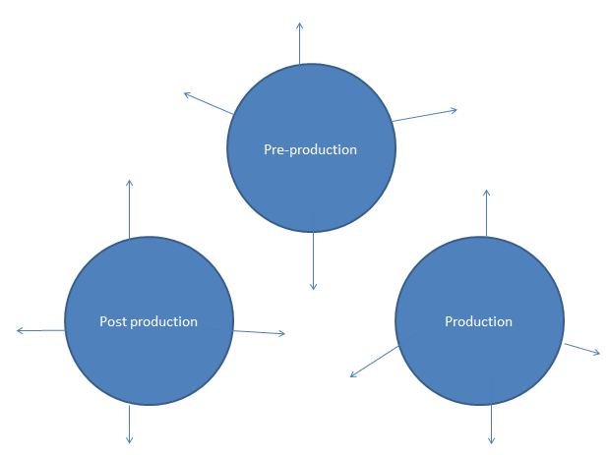

# Activity 2: Conglomerates v independent companies

Using your learning from Activity 1, you will now research one conglomerate and one independent company based on the media sector. You will use the space provided below to evidence your research:

**Name of assigned independent company: Wigwam Films** (<https://www.wigwamfilms.com/>)

**Name of chosen conglomerate company: Comcast** (<https://corporate.comcast.com/>)

Part 1 - You must find out about the following for each company**:**

1. Evidence that it is an independent company **OR** evidence that it is a conglomerate company (i.e. what are its subsidiaries? cross media ownership examples?).
2. Example of synergy.
3. Examples of joint ventures.

Part 2 - Based on your findings state what the similarities and differences are between the two assigned companies.

|  |  |
| --- | --- |
| **Similarities** | **Differences** |
|  |  |