Y8 History Home Learning

Introduction
For The National Archives the 2007 bicentenary of the Abolition of the Slave Trade Act is an important occasion. It represents an opportunity to broaden the public understanding of the significance of Britain’s involvement in the slave trade and slavery as well as its role in their eventual suppression and abolition. We will do this by promoting and providing access to our significant collections and online resources on these subjects, and make links to other archives with relevant collections. In particular, we hope to encourage new audiences to gain access to The National Archives to understand and interpret how slavery and the slave trade shaped the history of Britain, Africa and the former British empire in general, and to consider its consequences for modern-day British, African and Caribbean societies.

Britain and the transatlantic slave trade
The British were actively involved in the transatlantic slave trade. Forms of slavery were practised in British settlements and colonies, particularly in the Caribbean and North America, for around 200 years.
Britain was not the first country to enter the slave trade itself, nor the last to leave it. But during the time that Britain was involved (between 1660 and 1807) it turned the trade into a profitable business more than any other nation. At the height of the trade in the 18th century British ships carried more Africans than those of any other maritime nation. It is estimated that these ships transported over 3.1 million Africans across the Atlantic to the Americas. Approximately 2.7 million arrived – the others died during the notorious Middle Passage.
The Abolition of the Slave Trade Act was passed on 25 March 1807. However, ships that had lawfully been cleared to leave British ports before 1 May 1807 could trade until 1 March 1808. It is estimated that 34 ships left British ports for Africa after 1 May; the last slaving ship, the Eliza, left Liverpool on 16 August 1807. Several ships (including the Eliza) disembarked their slaves in February 1808. There is evidence that at least two ships legally traded after the 1 March deadline because they had been captured. These included the Robert, which arrived in Martinique (under British control) on 12 March, and Royal Edwards, which arrived in Surinam (also under British control) with 316 slaves on 3 October.
Throughout the duration of the transatlantic slave trade (started by the Portuguese in 1519 and ended in 1867) it is estimated that around 11 million Africans boarded ships to be transported to the Caribbean and America. Roughly 9.6 million survived the voyage to be sold into enslavement in the plantations, estates, mines and households of mainly European settlers.

The colonies
The British first successfully settled in the Americas in 1607 and in the Caribbean in 1623. Although Africans were among the early settlers it is uncertain what their exact status was – whether free settlers, indentured servants or slaves. Dutch planters from Brazil introduced sugar agriculture and African slaves to Barbados in 1640. It soon became apparent how much economic wealth could be gained from sugar. British colonies rapidly converted from predominantly white European settlements with small-scale agriculture aimed at domestic produce to slave colonies employing thousands of African slaves on large, white-owned plantations producing monoculture crops, mainly for export.
It is estimated that 361,000 Africans were transported to the North American colonies and another 2.2 million to the Caribbean. Slavery was abolished on 1 August 1834 but only children under the age of six were freed immediately under the terms of the 1833 Emancipation Act. Slaves in the Bahamas and Antigua were also freed at this point. All other former slaves were bound, as apprentices, to their former masters for periods up to a further six years. Laws were passed in the Bahamas and Antigua to abolish the apprenticeship clause, with political and public pressure forcing the other colonies to follow suit on 1 August 1838. For this reason 1838 is often considered to be the date that slavery was abolished in the Caribbean.

Relevant records held by The National Archives
The National Archives of England, Wales and the United Kingdom has one of the largest archival collections in the world, spanning 1,000 years of British history. We hold extensive records describing Britain's involvement in slavery and the slave trade, and their abolition. The important collections include:
- Colonial Office records describing how slavery shaped the history of Britain's former colonies, the abolition of slavery in the colonies, as well as Britain’s relationship with colonial governments on legal, social, military and economic matters in general;
- Records of British African companies describing Britain's early relationships with Africa and the supplying of Africans to the Americas;
- Britain's diplomatic, legal and naval roles in suppressing the slave trade and to its eventual international abolition;
- Slave registers containing personal details of enslaved persons;
- Records of the Slave Compensation Commissioners showing who was awarded compensation for the emancipation and the amounts they received.
The National Archives does not, however, have many records relating to the anti-slave trade movement or discussions leading to the abolition of the slave trade legislation. These movements were conducted directly through Parliament rather than by government departments.

Slavery

How did the Abolition Acts of 1807 and 1833 affect the slave trade?

Background

Racism
Enslavement is both a result and a cause of racism. A belief that certain people were racially inferior allowed Europeans to set up the trade in African enslaved people in the 1520s. It encouraged whites to believe that the cruelty of the capture of enslaved people, the inhuman conditions on the slave-ships and the incredibly harsh treatment the enslaved received in the Americas were somehow justified. Source 2 is just another example of this. Enslavement has also caused racism by setting up a stereotype of black people as victims in the past.

The triangular trade
The British trade in enslaved people was a three-legged voyage: from British ports to West Africa, where enslaved people were bought with guns and other British-manufactured articles. Then came the dreaded ‘middle passage’ to the Americas, with as many enslaved people as possible were crammed below decks. The enslaved were then sold in the southern USA, the Caribbean Islands and South America, where they were used to work the plantations. Plantations were farms growing only crops that Europe wanted: tobacco, sugar, cotton. The merchant ships would load up with these products and take them back to Britain on the last leg of their journey. Profits from this trade made merchants rich as well as providing the capital (money) for many of the enterprises of the early Industrial Revolution.

Plantation life
The enslaved people were worked in gangs, made up of both men and women, driven on by the whip of the overseer. They worked for ten to twelve hours a day in the tropical sun, for six days a week. Other enslaved people worked as craftspeople, or servants. The fact that they could be bought or sold away from the plantation at any time made it very difficult to maintain normal family life. Some of the ‘runaways’ listed in Source 1 may well have just been trying to visit friends or relations who had been sold to another plantation.
African songs, games, stories and religion helped to maintain the enslaveds’ belief in themselves. From the 17th century, gangs of runaways -called ‘Maroons’ in Jamaica – set up independent, permanent communities which resisted all efforts of the white owners and soldiers to crush them. Sometimes this broke out into open conflict, such as the Maroon Wars of 1730-1740 and 1795-6. There were also slave revolts, in Antigua in 1735, Tacky’s revolt in Jamaica in 1760, Kofi’s revolt in Guyana in 1763, in Granada in 1795-7, and so on.

Abolition
The case against enslavement had several arguments:
- the moral argument: enslavement is wicked, un-Christian
- the economic argument: enslavement is expensive and inefficient
- the legal argument: enslavement is illegal under British law
- problems in the plantations: enslaved people continued to resist enslavement and would not be suppressed
The campaign to abolish enslavement was the first popular peaceful mass protest movement of modern times. Leading white abolitionists were Granville Sharpe, who helped black people fight test cases in the courts; Thomas Clarkson, who collected evidence of the cruelty of the enslavement trade from all over Britain; and William Wilberforce, who fought for legislation in Parliament. They worked with black abolitionist campaigners, such as Olaudah Equiano and Ottobah Cuguano. Mary Prince, who had been enslaved for part of her life, wrote an important book about her experiences which helped to influence the eventual abolition of enslavement in 1833.
Clearly, the campaign to abolish enslavement did not end in 1833. Plantation owners still used forced labour in the form of indentured workers (a worker who works for a fixed term for their transportation, board and lodgings) particularly on tobacco plantations. Being an indentured worker meant, in theory, that you should be treated fairly and that although you weren’t paid for your labour, you would be given proper food and somewhere to stay. In actual fact, indentured workers were often treated no better than enslaved workers, with beatings, and even death, a common factor.
Enslavement goes on today. Look at the links on the right to find out about enslavement in the 21st century and its abolition.
As soon as Europeans began to settle in America, in the early 16th century, they imported enslaved Africans to work for them. As European settlement grew, so did the demand for enslaved people. Over the next 300 years more than 11 million enslaved people were transported across the Atlantic from Africa to America and the West Indies, and Britain led this trade from the mid-17th century onwards. Ports such as Bristol, Liverpool and Glasgow sent out many slaving ships each year, bringing great prosperity to their owners. Many other cities also grew rich on the profits of industries which depended on slave-produced materials such as cotton, sugar and tobacco.
The campaign in Britain to abolish slavery began in the 1760s, supported by both black and white abolitionists. The battle was long and hard-fought, with pro-slavery campaigners arguing that the slave trade was important for the British economy and claiming that enslaved Africans were happy and well-treated. However the frequent rebellions by enslaved Africans and evidence of the appalling conditions endured by them during and after transportation led to growing support for the demands to abolish the slave trade. Eventually, in 1807, Parliament passed an Act for the Abolition of the Slave Trade, which abolished the trade by Britain in enslaved peoples between Africa, the West Indies and America.
The pro-slavery campaigners had argued that with no new enslaved Africans being traded slave-owners would treat their existing slaves better. However, it was clear that enslaved people were still harshly treated and many continued to resist and rebel against their enslavement. In 1833 Parliament passed a further act to abolish slavery in the British West Indies, Canada and the Cape of Good Hope (southern Africa), meaning that it was now illegal to buy or own a person. However, slavery continued in other areas of the British Empire including the territories run by the East India Company, Ceylon (modern day Sri Lanka) and St Helena. Between 1808 and 1869 the Royal Navy’s West Africa Squadron seized over 1,600 slave ships and freed about 150,000 Africans but, despite this, it is estimated that a further 1 million people were enslaved and transported throughout the 19th Century.

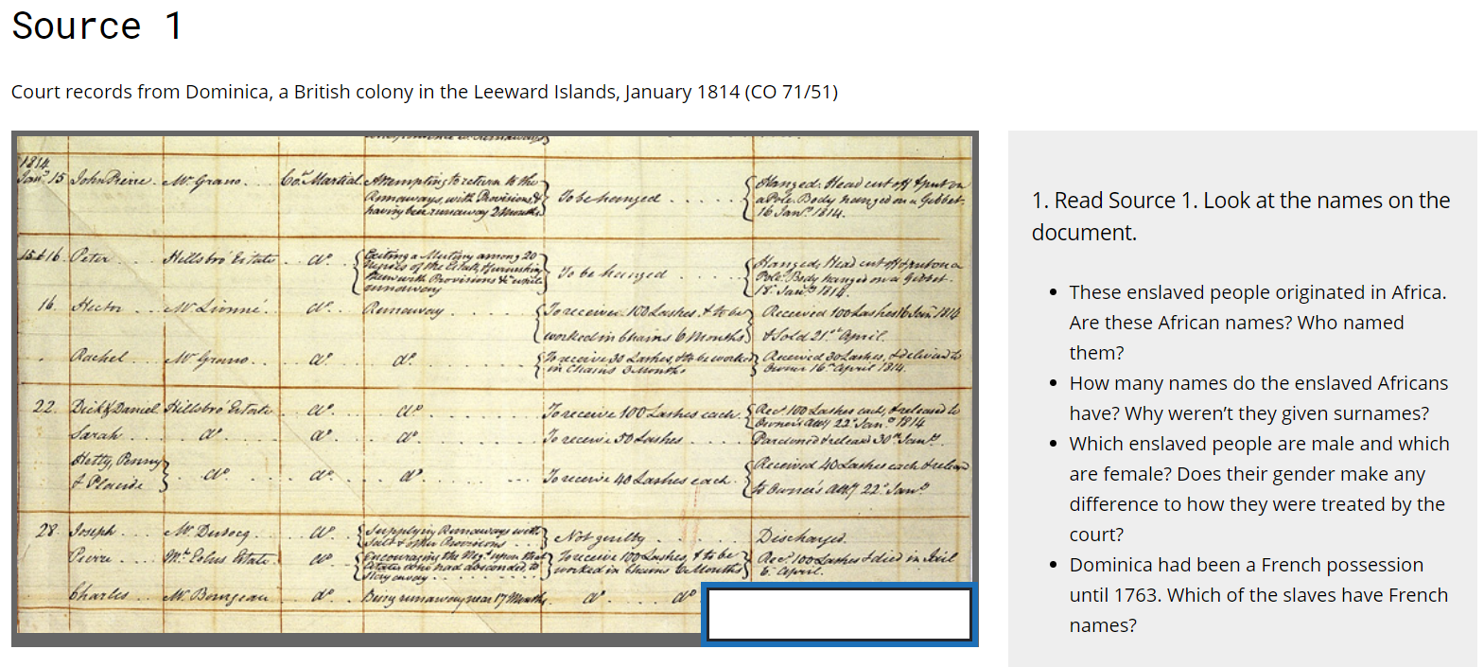
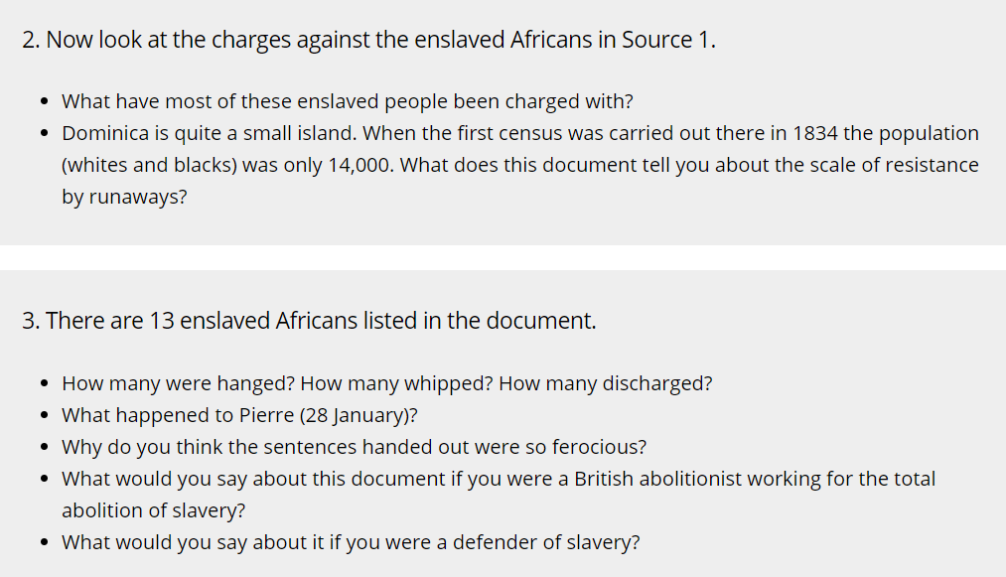
SOURCE 1 Transcript
1814  Jan[uar]y 15 | John Pierre | Mr Grano | 1814  Jan[uar]y 15 John Pierre Mr Grano Co[ur]t Martial | Attempting to return to the Runaways with Provisions & having been runaway 2 Months | To be hanged | Hanged : Head cut off & put on a Pole. Body hanged on a Gibbet, 16 Jan[uar]y 1814
15 & 16 | Peter | Hillsbro' Estate | ditto | Exiting a Mutiny among 20 Negroes of the Estate & harvesting them with provisions & while runaway | To be hanged | Hanged. Head cut off & put on a pole. Body hanged on a Gibbet 18 Jan[uar]y 1814
16 | Hector | Mr Lionne | ditto | Runaway | To receive 100 lashes & to be worked in chains 6 months | Received 100 lashes 16 Jan 1814 & sold 21st April
 | Rachel | Mr Grano | ditto | ditto | To receive 30 lashes & to be worked in chains 3 months | Received 30 lashes & delivered to owner 16th April 1814
22 | Dick & Daniel | Hillsbro' Estate | ditto | ditto | To receive 100 lashes | Rec[eived] 100 lashes each, & released to owners att[ention] 22nd Jan 1814
 | Sarah | ditto | ditto | ditto | To receive 50 lashes | Pardoned & released 30th Jan[uar]y
 | Hetty, Penny & Placide | ditto | ditto | ditto | To receive 40 lashes each | Received 40 lashes each & returned to owner's att[ention] 22nd Jan[uar]y
28 | Joseph | Mr Dubocq | ditto | supplying Runaways with salt & with provisions | Not guilty | Discharged
 | Pierre | Mr Polus Estate | ditto | Encouraging the Neg[roe]s upon that estates who had absconded to stay away | To receive 100 lashes & to be worked in chains 6 months | Rec[eived] 100 lashes & died in Jail 6 april
 | Charles | Mr Bonnjean | ditto | Being runaway near 17 months | ditto | Rec[eived] 100 lashes

4. Look at Source 2a, b and c.
Having been the largest slaving nation, Britain became a determined abolitionist power after 1833, using the Royal Navy to stop ships suspected of being slavers. These photographs were taken about 1868, off the east coast of Africa. They form part of a Report from John Armstrong Challice, a Lieutenant in the Royal Navy, working to abolish slavery in Zanzibar. Zanzibar did not abolish slavery until 1897.
- We know very little about these pictures. Use the clues you can pick out from the photographs to suggest what they actually show
- Write a brief description of the enslaved people – age, numbers, clothing, other conditions
- These photographs were taken about 1869, in the Indian Ocean. How useful are they as evidence of the Atlantic slave trade before its abolition in 1807?
- The ship on which these photographs were taken was the HMS Daphne, a British naval ship used to prevent the transportation of enslaved people. Do you think Britain had the right to act as the world’s police, stopping and searching ships of other nations? (Remember that Britain had been a large slave trading nation until 1833)
2a
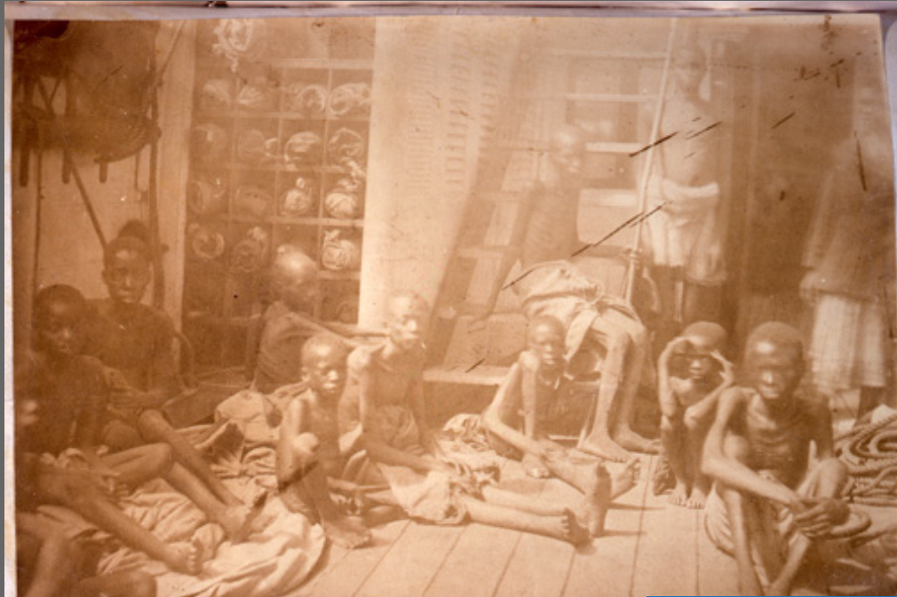

2b
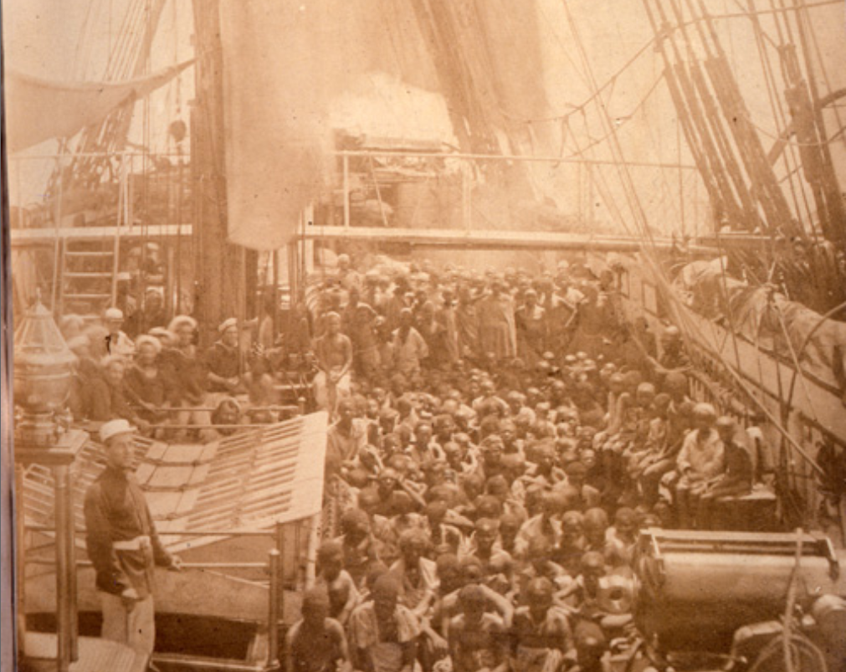
2c
