**Religion and Life**

Abortion

Abortion is the deliberate removal of the foetus from the womb. Each year there are over 180,000 abortions in England. It became legal in 1967 with strict criteria which is still in place but now so relaxed that almost anyone who wants one can have an abortion up to 24 weeks.

Some people think that abortion should be allowed based on the idea of the quality of life. Abortion can take place if the mother’s mental or physical health is at risk, or if there is something wrong with the foetus. {People argue that a child may have a poor quality of life if not wanted, or if the mother is too young or financially unstable.

Others would argue the sanctity of life. Both religious and non-religious people may say that life should not be just thrown away, that there are alternatives such as fostering or adoption.

[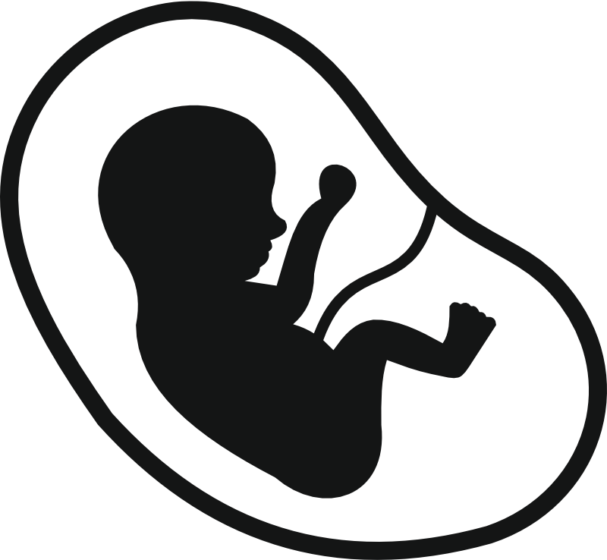](https://www.google.com/url?sa=i&rct=j&q=&esrc=s&source=images&cd=&ved=2ahUKEwjuuo2E0oXkAhXQWhUIHbfhB9QQjRx6BAgBEAQ&url=https://www.elifenetwork.com/home/foetus/&psig=AOvVaw2xRdOwMDLCRbVYtEkmu-_B&ust=1565984754747483)

**The use and abuse of the environment, including the use of natural resources, pollution**

Many would say that humans are abusing the environment. Science tells us that global warming is increasing due to human activity. Many of the world’s fossil fuels have been used, seas are over fished, and rainforests are being cut down. Many argue that our lives revolve around this and it is unrealistic to stop – scientists will solve the problems we will face.

Many people believe that we can change our habits. The Paris Agreement aimed to ensure many nations reduced their carbon foot print. More people are driving environmentally friendly cars and we reduce, reuse and recycle.

**The use and abuse of animals**

Animal experimentation uses animals to test things on such as medicines and cosmetics. Animals are often maimed and hurt, pain relief isn’t always given.

Some people would say that animal experimentation is an abuse of animals because:

* it is painful in many cases
* What works on an animal may not on a person as we are very different
* Experiments are often duplicated
* Christians don’t agree with using them to test non-essentials such as cosmetics due to ideas of stewardship

People may say that using animals for food isn’t right because:

* They are often kept in cramped conditions.
* There is no nice way of killing an animal
* There are alternatives to eating meat
* Eating meat contributes to global warming (cow trumps!)

[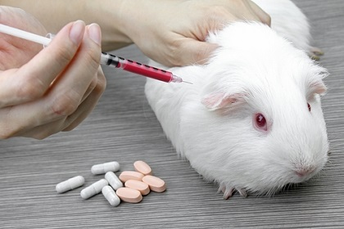](https://www.google.com/url?sa=i&rct=j&q=&esrc=s&source=images&cd=&ved=2ahUKEwiH1eOBuIXkAhVhs3EKHTjlCbUQjRx6BAgBEAQ&url=https://www.laboratoryequipment.com/news/2015/10/animal-experiments-don%E2%80%99t-use-safeguards-against-bias-says-study&psig=AOvVaw1SnxbFQGMKmkvsr_Bu3pUM&ust=1565977762024278)

Others would say that it is ok to use animals for these things because:

* It prevents harm coming to humans if experiments go wrong
* They are lesser than humans so it doesn’t matter what we do to them
* Religious people say that humans have dominion therefore we can do what we like.

**The value of human life**

Christians and Muslims believe in the **sanctity of life** – that all life is precious and God given. This means that anything that deliberately takes life is usually not allowed.

“I knew you in the womb” – The Bible

Many people believe in **quality of life** – the idea that life must have enough benefits to be worth living.

**Euthanasia**

This means a ‘**gentle and pain free death’**. Some people want to die due to poor quality of life or because they have a terminal illness which means that they are likely to die in pain. Some people want assisted suicide – someone gives them the means to kill themselves. This is illegal in the UK but allowed in places such as Switzerland.

Some people believe that people should be helped to die because it is the most loving thing to do. It shows compassion to someone to help them to die e.g. someone with Locked in Syndrome who wanted to die. We have the human right to live, surely people have the right to die?

Some argue that the sanctity of life means that it isn’t right. The bible teaches “Do not kill” People may also abuse relatives for money if it was allowed and manipulate them in to wanting to die to not be a burden. Hospices provide pain relief and help people mentally which means that an early death may not be necessary.

**Beliefs about death and an afterlife**

Christians and Muslims believe there is life after death because their holy books say so. They believe that the good will go to heaven and the bad will go to hell, as taught in the parable of the sheep and goats. Heaven is a place of wonder and paradise whereas hell is a place of torment. Some think this is because God isn’t there.

Some Christians believe in immortality of the soul – that people go to heaven or hell straight away – Jesus said to the criminal ‘today you will join me in paradise’. Other Christians and Muslims believe in resurrection – that nothing happens until the Day of Judgement when God will judge.

Non-religious people have different views. Some people believe in ghosts and psychics who they think are evidence of the afterlife. Others think that this is made up, or people just wanting hope and comfort.

**Their impact on beliefs about the value of human life**

For believers, belief in the afterlife means that they try to behave well in order to get to heaven e.g. follow the Decalogue and do things which will please God.

**Origins of the universe**

This means different beliefs people have about how the universe, and world, was made. Religious believers have creation stories, but many believers also believe scientific theories due to evidence for them.

Some Christians believe that the Bible is literally true, and therefore believe that the universe and world were made by God. There seems to be two Creation stories. In Genesis 1 God created the world in six days, making humans on the last day. “God said ‘let there be light’… and it was good’. Genesis 2 teaches that man was made out of clay, and Eve was made from Adam’s rib and was made as his companion.

* Some Christians believe that these stories are true as they think that the Bible is the word of God.
* Others think that the days represent periods of time, not 24 hours.
* Others think that the Bible was created to explain the power of God, and should not be treated as fact.

[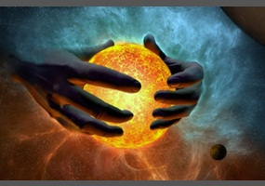](https://www.google.com/url?sa=i&rct=j&q=&esrc=s&source=images&cd=&ved=2ahUKEwjUg5ze0YDkAhUPAmMBHW9BApQQjRx6BAgBEAQ&url=https://www.debate.org/opinions/is-the-creation-story-from-the-bible-true-please-state-evidence-evidence-against-evolution-does-not-prove-creation-true&psig=AOvVaw1nsK5fkOiTmAbw-_muaZjQ&ust=1565812865841760)

Many religious and non-religious people believe in theories such as the Big Bang Theory due to the scientific evidence for it. Red shift shows that the universe is expanding, and fossils show that evolution occurred on Earth.

* Many people agree that this seems more plausible due to the evidence. Religious believers may say that God caused the Big Bang to happen and so religion and science are not at odds with each other.
* Some Christians totally disagree with this and argue that the Bible teaches that the Earth is only 10,000 years old. They may say that fossils were out in earth by God to fool people and test faith.

**The value of the world, and human’s role in it**

When Christians look at the world they feel **awe and wonder** – amazement at how everything natural is perfect. The see it as a reflection of God’s power and love for his people – providing everything they need. For many, looking at the world inspires them to believe in God.

**Stewardship** means taking care of the world now and for future generations.

**Dominion** is the belief that the world is ours to do with as we like.

In the past most religious people believed that we had dominion over the world. There are many teachings to support this ‘Rule over the fish in the sea, the birds in the sky.’ God also said that animals should ‘fear’ humans. This led humans to over fish, burn and use up fossil fuels, and take away habitat leading to the near extinction of many animals.

[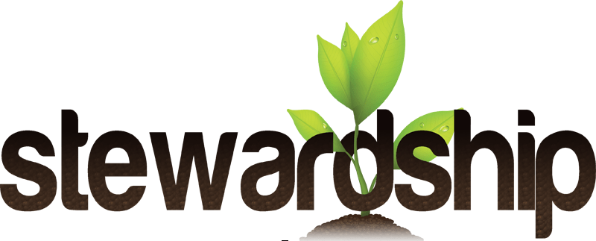](https://www.google.com/url?sa=i&rct=j&q=&esrc=s&source=images&cd=&ved=2ahUKEwih2Zzi_YLkAhUSzoUKHaJqD1cQjRx6BAgBEAQ&url=https://research.csiro.au/seltmp/aspirations-capacity-stewardship/&psig=AOvVaw1wqDXJ0_umhAMFoZ3xyd10&ust=1565893110546689)

In more recent time religious people believe that we should be stewards. The Earth was made by God and belongs to him and so we should not harm it. They interpret the above quote to mean that ‘rule’ means ‘care for’. Also, taking care of the earth also takes care of people. Global warming effects the poorest the most and so by looking after the earth Christians are also following ‘love your neighbour’. Christians and Muslims believe that Adam was given the first role as steward and humans have a responsibility to care for it now for generations to come.