**Weapons of mass destruction (WMD)**

These are weapons which cause damage to people and the environment indiscriminately – they hurt anyone in their path regardless of whether they are a civilian or military. WMD are nuclear weapons, biological weapons or chemical weapons. Most people are against their use because they hurt innocent people and damage the environment. An example of the use of each weapon is:

* Nuclear: During WWII the US bombed Hiroshima in Japan killing thousands almost instantly
* Biological – 2001 anthrax was mailed to news media centres and senators killing 5 people
* Chemical – 1995 sarin gas was released during a terror attack on subway in Tokyo, Japan killing 12 people

Nuclear weapons

All religious people **are always against** their use due to ‘do not kill’, ‘love your neighbour’, the Golden Rule etc., they harm innocent people and bring suffering.

Some religious people may agree with having them **but not using them** as they act as a deterrence. This can prevent war as no-one would attack as it would mean mutually assured destruction.

Some people would argue that they are pointless as most countries will never use them so what’s the point in having them, they also are costly to build, replace and maintain.

**Peace-making in the contemporary world**

A non-religious organisation is the United Nations. This is a group of 193 countries who try to keep world peace through trade sanctions, diplomacy and their peace keeping army.

Pax Christi and Christian Aid both work for peace though using the millions of Christians worldwide to support each other. They try to stop causes of war through giving aid to troubled areas, they lobby governments to try to intervene, they give sermons on the need for peace etc.

**Helping victims of war**

All believers think that helping victims of war is good. These people are innocent and made ‘in the image of God.’ Jesus taught people to ‘love their neighbour’ and the Golden Rule. War causes suffering to people and the aim of Buddhism is to relieve suffering. Muslims follow the teaching ‘love your neighbour near and far’ and believe that everyone is a member of the ummah – the Muslim community.

**Religion as a cause of war**

In the world today there is strong belief that religion causes war. This can be the case when you think of ISIS and the actions of the IRA in Ireland, however usually there is political motivation too. 93% of wars are caused by something other than religion e.g. wars in Syria and Libya was caused by oppression of the people by their leaders.

Others would argue that religion does cause conflict e.g. ISIS believe that traditional Islam is the correct religion that should be followed.

Holy War

This is a war fought in the name of religion e.g. the Crusades. The Bible and Qur’an teach that holy wars can be fought. In Islam a holy war has rules which are virtually the same as the Just War Theory. The only exception is that farm land must not be deliberately destroyed to ensure that people can get back to normal as quickly as possible. Islam is clear that war should not go too far, do what is necessary but no more – ‘Do not transgress, for God hates transgressors.’

[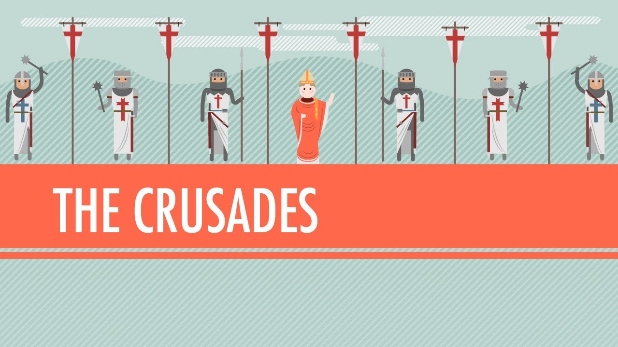](https://www.google.com/url?sa=i&rct=j&q=&esrc=s&source=images&cd=&ved=2ahUKEwihxYfVlo3kAhVNKuwKHc4hA8UQjRx6BAgBEAQ&url=https%3A%2F%2Fwww.youtube.com%2Fwatch%3Fv%3DX0zudTQelzI&psig=AOvVaw1xqoqYELMtZ9Rp0cACZwXn&ust=1566243679367970)

**The Just War Theory**

Just means fair. This is a set of rules which tells Christians:

1. When it’s ok to go to war and be fair
2. How to act when at war and be fair

It was created by St Aquinas as Christians were unsure how to follow Jesus’ teachings about love yet live in a world where war was always around them. To be a Just war ALL rules need to be followed.

1. It must be declared by those in authority
2. There must be a just cause
3. There must be a reasonable chance of success
4. The intention behind the war must be good
5. All other ways of resolving the problem should have been tried first
6. The means used must be in proportion to the end that the war seeks to achieve
7. Innocent people must not be deliberately targeted
8. Only appropriate force can be used

**Religion, Peace and Conflict**

**Violent protest**

Many Christians believe that violence is not the answer. People often get hurt which goes against “Do not kill, ‘love your neighbour’ and the Golden Rule. It also goes against St. Paul ‘Obey the State authorities’. Martin Luther King showed that non-violence works.

Others say that sometimes it is necessary as other ways don’t always work. Bonhoeffer used violence to try to kill Hitler as other methods just didn’t work. He said it was the ‘most loving thing’ and he was showing love to his neighbour.

**Terrorism**

This is when a group of people use violence to get governments to give them what they want e.g. ISIS.

All religions think that terrorism is wrong as it is unjust and kills innocent people which goes against the Decalogue, ‘love your neighbour’ and the Golden Rule.

**Reasons for war**

There are many reasons for war, often they are a combination of factors.

**Greed**: ne country or people want what another has and tries to take it. Christians are against this as it breaks the Decalogue ‘Do not covet’ and it is against the Golden Rule.

**Self-defence**: One country or people must defend themselves if attacked e.g. World War II. The Pope said that it is a duty to defend each other.

**Retaliation**: One country is attacked and so they try to get back at the attackers e.g. war on terror in Afghanistan and Iraq after the Twin Towers attack. Religious groups are divided on this due to teachings such as ‘eye for an eye’ and ‘blessed are the peace makers’ which suggest different things.

Other reasons can be social, political and moral (defending people who can’t defend themselves).

**Pacifism**

This means people refusing to fight as a way to keep the peace. Many people think that not using violence is the best way to solve problems. People can protest, hold peace talks, countries can issue sanctions to force a country to behave. If people don’t retaliate then it shows them to be the better person (as Martin Luther King did). Many would argue that **forgiveness** and **reconciliation** are better than violence as it allows people to move on and prevents war breaking out again, or continuing. Corrie Ten Boom and Eric Lomax are examples of people who forgave and reconciled with their enemy, both said it actually made them feel better.

[](https://www.google.com/url?sa=i&rct=j&q=&esrc=s&source=images&cd=&ved=2ahUKEwj4o_LXkYjkAhUK6RoKHToxBxUQjRx6BAgBEAQ&url=https://en.wikipedia.org/wiki/Pacifism&psig=AOvVaw3x7QI9ZWDi-xRn5Z0pel7M&ust=1566070571352071)

Many Christians support pacifism as Jesus said “Blessed are the peacemakers.” Also, it follows the Decalogue “Do not kill” and Golden Rule etc. Keeping the peace prevents death and destruction which destroys God’s creation. Forgiveness and reconciliation also follows ‘forgive not seven times but seventy times seven.

**War and violence**

Some may argue that actually war is necessary, even though it is not liked, as it can lead to justice. At times war can be the ‘lesser of two evils’ e.g. if defending people such as in WWII. Sometimes a country has to fight back or seem weak which leads them open to further attack e.g. Britain had to fight for the Falklands

[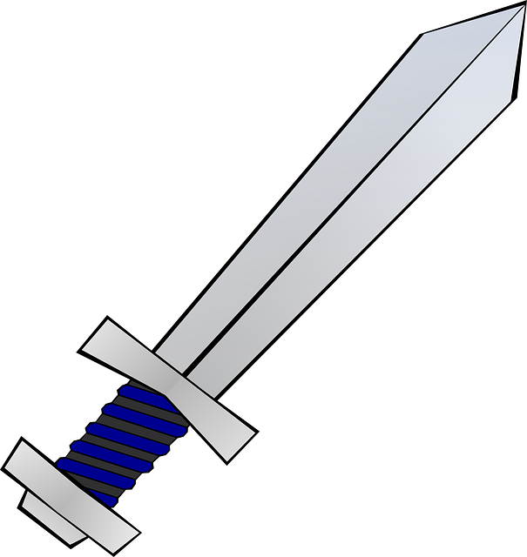](https://www.google.com/url?sa=i&rct=j&q=&esrc=s&source=images&cd=&ved=2ahUKEwiBrNjK3orkAhUMCxoKHeYVCpUQjRx6BAgBEAQ&url=https://ui-ex.com/explore/drawing-sword-cartoon/&psig=AOvVaw2yNIjAB2QT8lBo_sD2tZjH&ust=1566159907789492) [](https://www.google.com/url?sa=i&rct=j&q=&esrc=s&source=images&cd=&ved=2ahUKEwiYnvOA34rkAhUNfBoKHQy-A04QjRx6BAgBEAQ&url=https://abeon-hosting.com/cartoon-tank-png.html&psig=AOvVaw0FtBK5o6NEC3z5kUm9zfmr&ust=1566160018715002)

Some Christians think that war may be acceptable because in the Old Testament it teaches ‘God is war’ and there are many examples of God instructing people to fight in his name. The Just War Theory also allows war under certain conditions, and the Bible teaches ‘an eye for an eye’. The Qur’an teaches that Muslims who die in holy war will go to paradise. Jesus also said ‘if you don’t have a sword, sell your cloak and buy one.’