**Heterosexual and homosexual relationships**

**Heterosexual** relationships are relationships between men and women and for centuries were considered ‘normal’ as they can reproduce naturally. 85% of the population are heterosexual. **Homosexuality** is sexual attraction to the same sex. For centuries people were outcast and even sent to prison for being gay in the UK, around the world people are still severely punished. Modern attitudes realise that a person’s sexuality is out of their control and in more recent years same sex marriage has been legalised in many countries and equal rights given the same as those given to heterosexual couples.

The Bible teaches that “A man shall leave his father and mother, unite with his wife, and the two shall become one flesh” so many Christians believe that this is what God intended.

* However, Christians also argue that God does not make mistakes and if a person is gay then God made them that way. Humans are made in the ‘image of God’.

There are many Bible passages which seem to homosexuality is wrong e.g. Leviticus: ‘If a man lies with a man as one lies with a woman, it is an abomination’, and the story of Sodom and Gomorrah says that God destroyed the cities due to the ‘wicked acts’ of the people (homosexual relationships).

* However, Leviticus contains lots of rules which Christians don’t follow anymore, also the translation of the Bible may suggest that the ‘wicked act’ was how people were treated and not the homosexual acts.
* Also, Jesus taught about love and compassion for all, this would include homosexuals.

Some people argue that the purpose of a couple is to reproduce therefore homosexuality is wrong as it can’t do this.

Others would argue that people can adopt or use IVF or surrogates to have children and so that argument doesn’t stand.

**Sex before and outside of marriage**

Muslims and many Christians do not accept sex before marriage and ALL do not allow sex outside of marriage (adultery). The Bible and Qur’an teach that sex should only be within marriage. St. Paul said it is better to marry than ‘burn with lust’ and Genesis says a man will ‘unite with his wife’. In Islam Shari’ah law gives harsh punishments for pre-marital sex and adultery, and boys and girls are not allowed to mix unaccompanied from puberty to avoid temptation. The Bible teaches “Do not commit adultery”. Both religions would say that adultery can break up families which is wrong as the family is very important.

Other Christians allow sex before marriage (pre-marital sex) as it is an expression of love. Many also allow it if a couple intend to marry as it is better to see if you are compatible and avoid divorce later on. Also, many Christians would argue that God will forgive.

**The nature of families**

Role of parents and children: Christians and Muslims believe that the family unit is very important and there are many roles within it. The role of the parents is to care and nurture their children. This can mean disciplining them when necessary (The Bible teaches ‘spare the rod, spoil the child’), teaching them about their faith through taking them to worship or praying together at home, caring for each other in good and bad times.

The role of the children is to obey their parents (it’s one of the Ten Commandments – ‘Honour your father and mother’), they also should care for them when they are elderly.

**Extended families**: These are families where parents and children live with, or very close to, other relatives such as grandparents, aunts and uncles. It means that all members of the family pull together to take care of each other.

[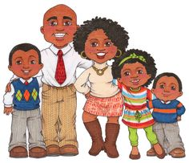](https://www.google.com/url?sa=i&rct=j&q=&esrc=s&source=images&cd=&ved=2ahUKEwjahMiphP7jAhVryoUKHXi0A90QjRx6BAgBEAQ&url=https://www.pinterest.com/image_queen/clipart-family/&psig=AOvVaw1Xn3BUFheh8-_-UlmpyJVd&ust=1565723365709443) [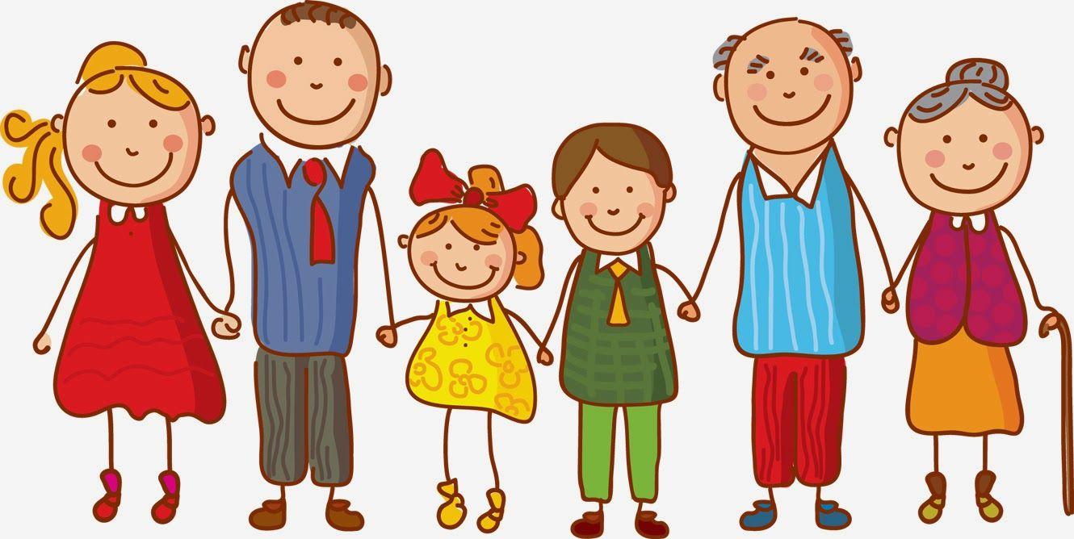](https://www.google.com/url?sa=i&rct=j&q=&esrc=s&source=images&cd=&ved=2ahUKEwiGyZ39g_7jAhXpzoUKHffgCTUQjRx6BAgBEAQ&url=https://www.pinterest.com/pin/495325659007323994/&psig=AOvVaw0yggAQIGdXygvWX9DtB7uH&ust=1565723293374149)

Nuclear family: This is a common type of family in the UK – parents living with their children.

**The purpose of families**

Both Muslims and Christians think that the family has many purposes:

* The family unit is the place for the procreation of children. This is because it provides both parents to raise the child.
* Also, it provides stability and protection for children. Parents are expected to love and care for their children. In Islam Muslims will be judged on how well they have looked after them.
* The family is also used to educate children in the faith. This could mean taking the children to Sunday school, or praying together. Children will learn stories and teachings from the Qur’an and grow up understanding what it means to be a good Christians/Muslim.

**Divorce and remarriage**

In the UK 1 in 3 marriages end in divorce. This is the same for religious and non-religious families.

Some Christians do not allow divorce: The couple say vows which are promises made to each other **and to God** during the ceremony; one is love until ‘death til us part’ meaning only death can end the marriage. Also, families destroy the family unit. Jesus also said that if a man divorced his wife and married again then he committed adultery.

[](https://www.google.com/url?sa=i&rct=j&q=&esrc=s&source=images&cd=&ved=2ahUKEwiom4Tis_3jAhWD2uAKHUurBYoQjRx6BAgBEAQ&url=https://www.iamexpat.nl/expat-info/dutch-expat-news/divorce-career-and-children&psig=AOvVaw3JX6tDuteSfWYtmK9QCnr-&ust=1565701755803546)

However some Christians may allow it in certain circumstances, however they will still not like it as it is the most compassionate thing to do. Teachings such as ‘love your neighbour’ mean that if someone is unhappy or in an abusive marriage then the loving thing to do will be to allow them to divorce. Christians also have the belief that God is forgiving and so would allow divorce. Muslims allow divorce as marriage is a contract and not necessarily for love. If a couple aren’t working they should be free to marry someone else.

Some Christians allow divorce but not remarriage as they say that marriage vows can only be said once and so remarriage is not possible. Some Christians will allow remarriage in a church, others won’t. It depends on the individual vicar.

**Family and Relationships**

**Contraception and family planning**

Contraception is using artificial means to prevent pregnancy. Family planning is deciding when, and how many children, to have.

Some Christians and Muslims disagree with its use as they believe that only God should decide. Sex was given for reproduction and so to avoid pregnancy goes against God and is a sin. God said “Go forth and multiply”. Reproduction also ensures the faith is continued. Some forms also allow pregnancy to happen (morning after pill). Most Christians do not allow this as it is seen as the same as abortion which is wrong – “Do not kill”, the sanctity of life.

Others allow it as sex can also be to express love, not just have children. Some families can’t afford to have many children, or pregnancy could be dangerous for some women and so it is the most loving thing to do and follows the Golden Rule. Also, there is evidence that Muhammad knew that some people used the withdrawal method and didn’t object to this,

**Religion and gender equality**

Some Christians will support gender equality as all were made ‘in the image of God’. Also, it follows the Golden Rule. Jesus was close friends with women, and it was women who first realised that he had risen from the dead.

However, some Christians believe that men are superior to women as woman was made from Adam’s rib as his companion. Jesus was very outspoken yet still chose not to have women as disciples. Also, the priest represents Jesus therefore a woman couldn’t have this role.

**Gender equality**

Gender equality means treating males and females in the same way.

Some people say that there is gender equality due to the laws we have in place e.g. Sex Discrimination Act. Also, there are many jobs that both genders can have e.g. both can be in the military, run companies etc.

Some would argue that there still isn’t gender equality as women still find it hard to achieve top jobs, and can’t be priests in some religions egg Islam. Only around 32% of UK MPs are women.