

Our ref AH/ETD

12th September 2016



Headteacher: Mrs Maura Favell BA (Hons), MA

Deputy Headteachers: Miss Jo Howell

Mr Adrian Boulstridge

Mrs Alexis Rickus

Dordon Rd. Dordon, Tamworth, Staffordshire B78 1QT

Tel: (01827) 702205, Fax: (01827 702206)

Email: [admin@thepolesworthschool.com](mailto:admin@thepolesworthschool.com)

Website: www.thepolesworthschool.com

Dear Parents/Carers

**RE: Placement of students on appropriate courses for GCSE**

The Science Department have been reviewing the current level of demand for GCSE courses and how students for Year 9 are placed into appropriate groups for their continued study of Science in Year 10 and Year 11. We feel that it is right to provide all students with the opportunity to study Science GCSEs.

Combined Science is a Double Award course including content from Biology, Chemistry and Physics but which gives the student two GCSE Science Qualifications of the same grade at the end of Year 11. There will also be the opportunity for a smaller proportion of students to study separate Biology, Chemistry and Physics GCSEs with separate grades, often referred to as Triple Science, beginning in Year 10. The individual Science GCSEs are very demanding and students wishing to take these courses would be expected to meet the criteria outlined below by the end of Year 9.

Criteria for entry onto Individual Science GCSE courses (Triple Science) at the start of Year 10 are as follows:

1. Consistently produce topic assessment marks that are step 8 or above throughout Year 9.
2. Achieve step 8 or above on the end of Year 9 internal examination covering all of the areas of learning from the Year 9 programme of study.
3. Teacher assessment of the student’s behaviour for learning and commitment to Science over the course of Year 9 must be at least good and will be reflected by the Skills for Learning comments on their reports.

Assessments in Science during Year 9 will include the two interim assessments on the whole school Assessment Schedule previously sent to parents. Further assessments will take place after each unit of work is completed. The assessments will take the form of examination questions carried out under controlled conditions within lesson time.

Please contact either myself or Key Stage Coordinators within the Science Department if you have any further questions.

Yours sincerely

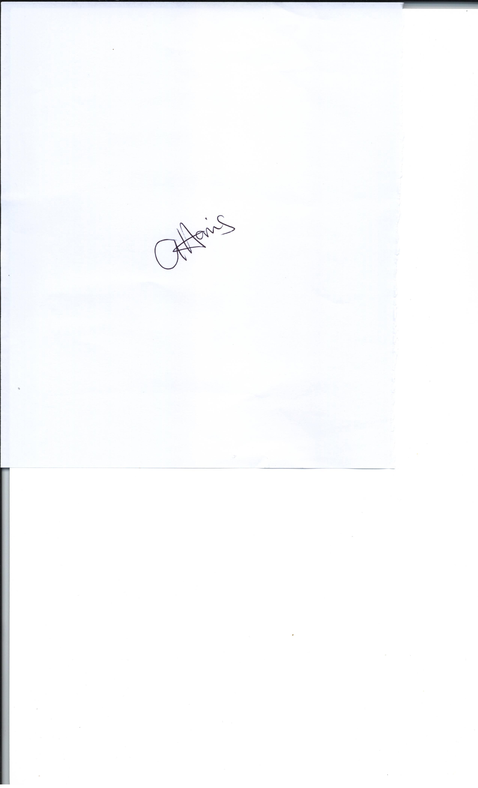

Miss A Harris

Head of Science