

Our ref AH/ETD

12th September 2016

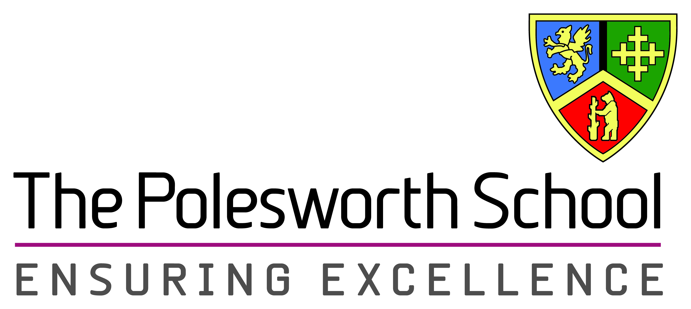

Headteacher: Mrs Maura Favell BA (Hons), MA

Deputy Headteachers: Miss Jo Howell

Mr Adrian Boulstridge

Mrs Alexis Rickus

Dordon Rd. Dordon, Tamworth, Staffordshire B78 1QT

Tel: (01827) 702205, Fax: (01827 702206)

Email: [admin@thepolesworthschool.com](mailto:admin@thepolesworthschool.com)

Website: www.thepolesworthschool.com

Dear Parents/Carers

**RE: Examination arrangements for Year 11 set 2 and 3 Science classes**

This letter is to inform you about the arrangements for your child's Science GCSE examinations this year. You will know already that we have mock examinations which take place in December of Year 11; students in sets 2 and 3 will complete higher tier papers in all three sciences: Biology, Chemistry and Physics. On marking these mocks we will then recommend foundation tier entry for any students who achieve a D grade or U grade in any of these papers. It is possible for a student to complete higher tier in one Science and foundation tier in another, with any marks scored in a higher tier paper counting for more UMS in their overall Science GCSE. Students can still achieve up to a B grade even when sitting foundation tier papers in all three sciences. On using this model in 2015-2016 we found that many students met or exceeded their target grades.

**What can I do to help my child prepare for their mock examinations?**

To ensure your child is well prepared, confident and performing at their best for these examinations, he or she should now be working hard on revision both at school and at home. Your child should ensure they complete all their science homework to the best of their ability, and when they run into any difficulties they should be seeking help and advice. Students should now be setting several hours a week aside for quiet, well focused study of science. You can support your child by ensuring that they have a quiet place to study and by testing them on their subject knowledge. The following sources of assistance are available and should be used by all students at some point in their preparation:

* Revision guides available on Parent Pay.
* Revision resources on the school website under Curriculum, Departments, Science, Key stage 4 revision or Key stage 4 – year 11.
* Past papers on the AQA website: <http://www.aqa.org.uk/subjects/science/gcse/science-a-4405/past-papers-and-mark-schemes> (the mock exams will be unit 1 papers for Biology, Chemistry and Physics).
* Exercise books from year 9, 10 and 11.

In addition to this there are several apps for Science revision such as BBC bitesize and Gojimo.

Please contact either myself or Miss R Wilkinson (KS4 Coordinator) if you have any further questions.

Yours sincerely

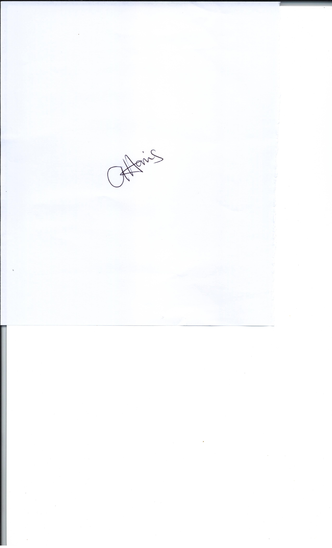

Miss A Harris

Head of Science