Section | Title  - Key Areas to revise | Date revised |  |  | Past paper mark
C2.1 and C2.2  Structure and Bonding. | Atomic Structure Review  - Know the subatomic particles that make up an atom.  - Recognise and state the charges and masses of each sub atomic particle.  - Identify an isotope as being an atom that contains the same number of protons but different numbers of neutrons.
Atomic Structure Past Paper Questions:

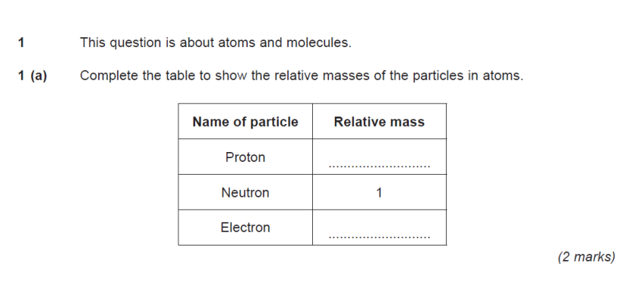

Ionic Bonding
- Know that Metal elements react together with non-metal elements to form ionic compounds by gaining or losing electrons (ionic bonding).
- Describe ionic bonding in terms of strong electrostatic forces of attraction between oppositely charged ions.
- Explain why ionic substance has high mpt and bpt/conduct electricity when dissolve or molten based on the bonding.
- Construct dot and cross diagrams for ionic compounds (magnesium oxide and calcium chloride.
- Be able to write the formula of an ionic compound from its ions.

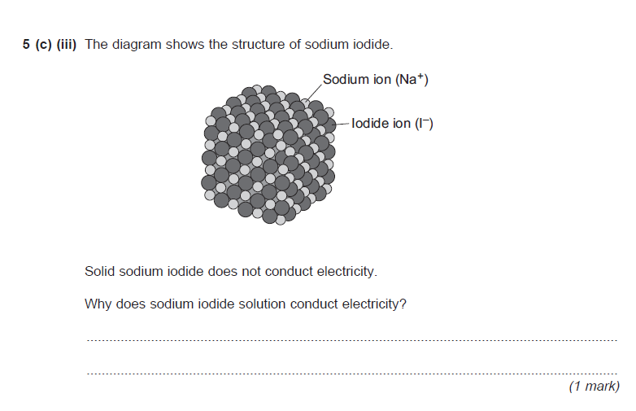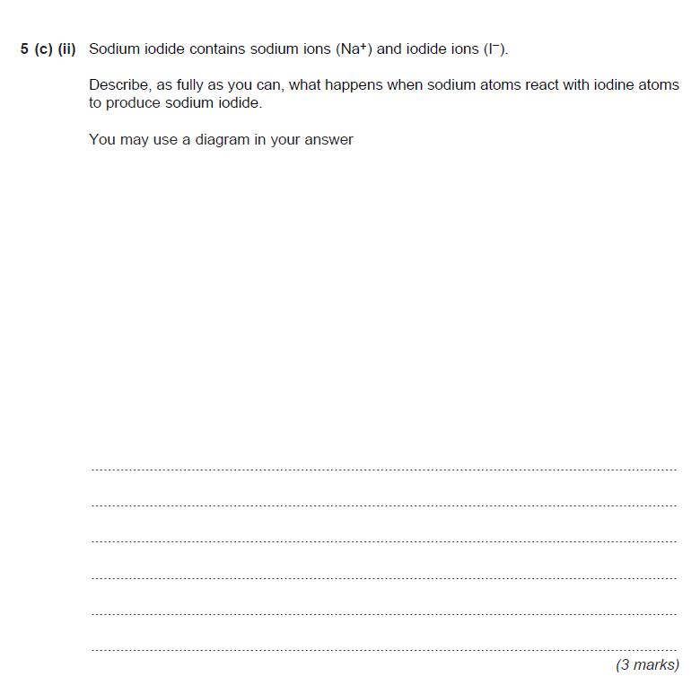
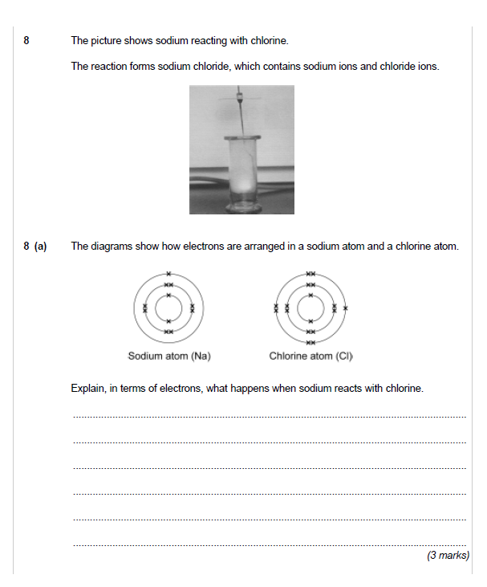
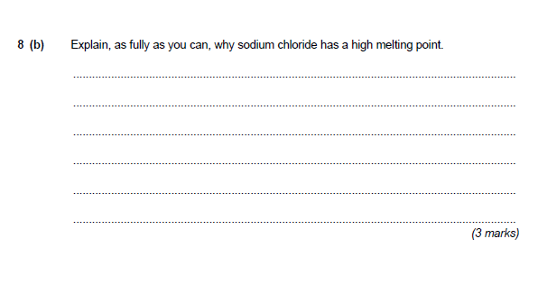
Covalent Bonding
- Define covalent bonding as a shared pair of electrons between atoms.
- Draw dot and cross diagrams for simple covalent compounds (H₂, Cl₂, HCl and H₂O).
- Describe covalent bonds as very strong.
- Explain that in simple covalent compounds the molecules are held together by weak intermolecular forces and leads to them having low melting/boiling points.
- Giant covalent structures such as diamond, graphite, fullerenes and silicon dioxide are made lots of strong covalent bonds and have high melting/boiling points.
- Know why diamond is hard and graphite is slippery.
- Describe why graphite can conduct electricity but other macromolecules can’t.
- Recall structures of fullerenes (large hexagonal ring structures of carbon atoms)
- Be prepared to describe their uses based on above info- comprehension type questions where much info is given in the question.

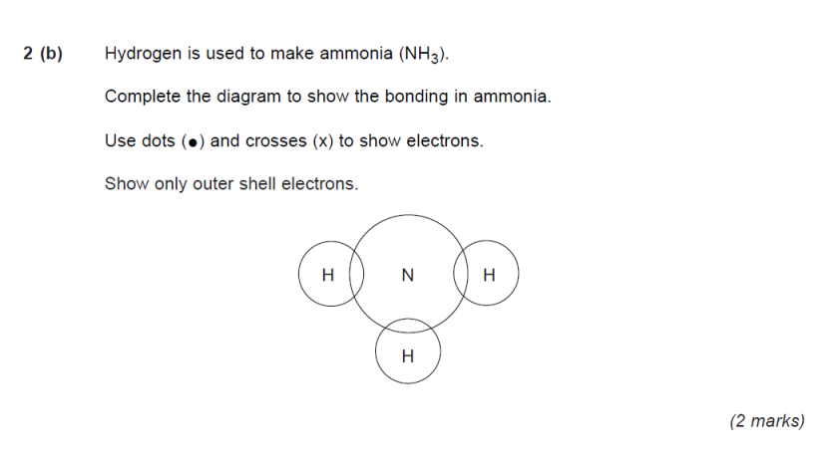
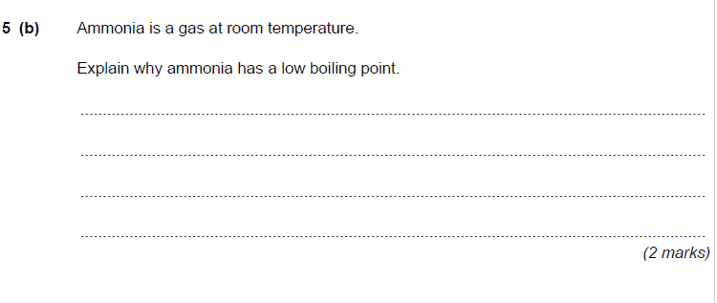
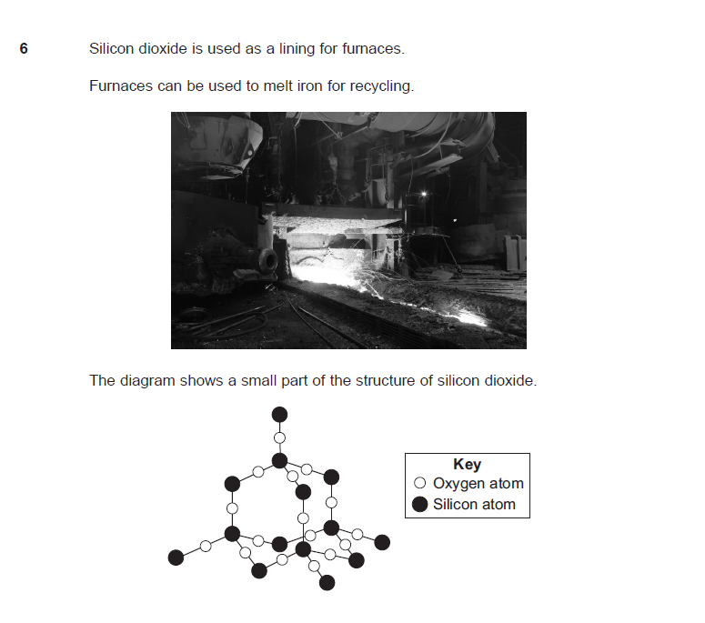
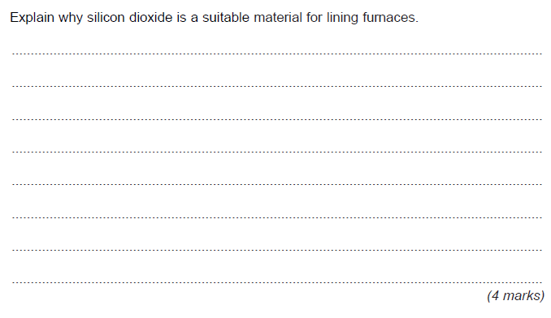

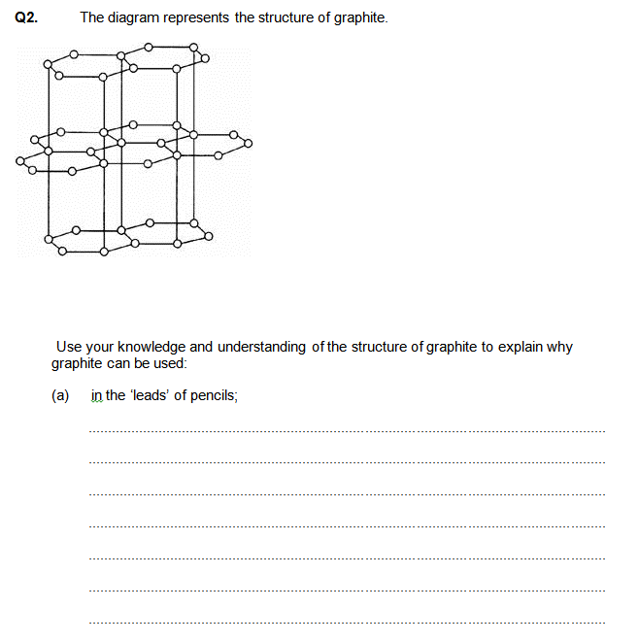
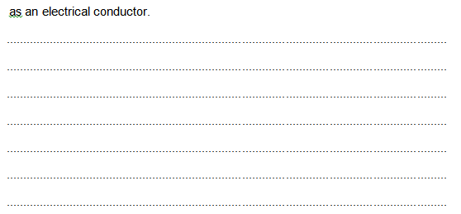
Q5. The diagram shows the structure of diamond.
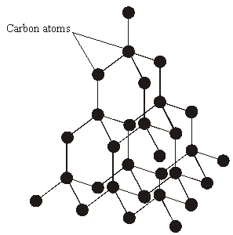
(a) To gain full marks for this question you should write your ideas in good English. Put them into a sensible order and use the correct scientific words.
Explain, as fully as you can, why diamond has a high melting point.
.......................................................................................................................
.......................................................................................................................
.......................................................................................................................
.......................................................................................................................
.......................................................................................................................
.......................................................................................................................
(3)

Section | Title  - Key Areas to revise | Date revised
C 2.1 and 2.2 | Metals  - Know that the atoms in metals are closely packed together and arranged in layers this causes them to be malleable.  - Describe how the positively charged ions are held by the electrons from the outermost shell of each metal atom.  - Delocalised electrons are free to move throughout the giant metallic structure and allow metals to conduct electricity.  - Define shape memory alloys.
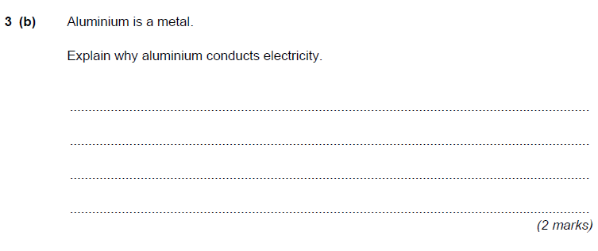
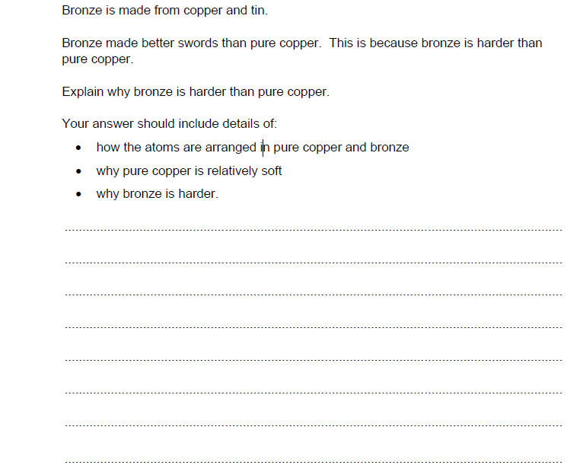
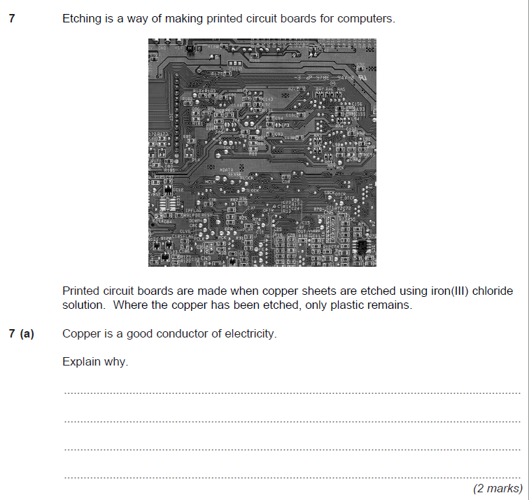
Polymers
- Know that the monomers and the reaction conditions can change the properties of the polymers made.
- Recognise diagrams of thermosetting and thermo-softening polymers and describe properties in relation to cross links.
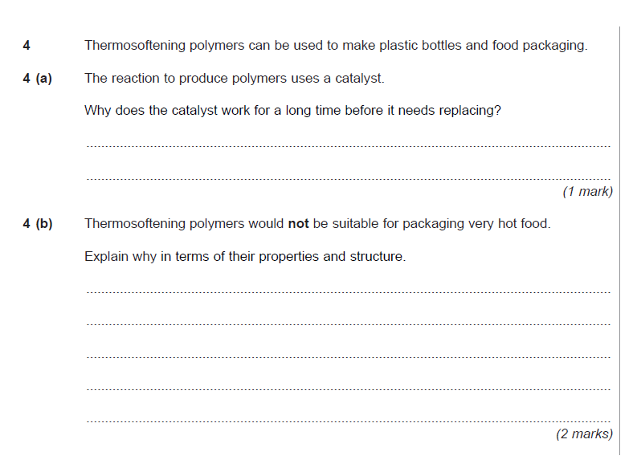
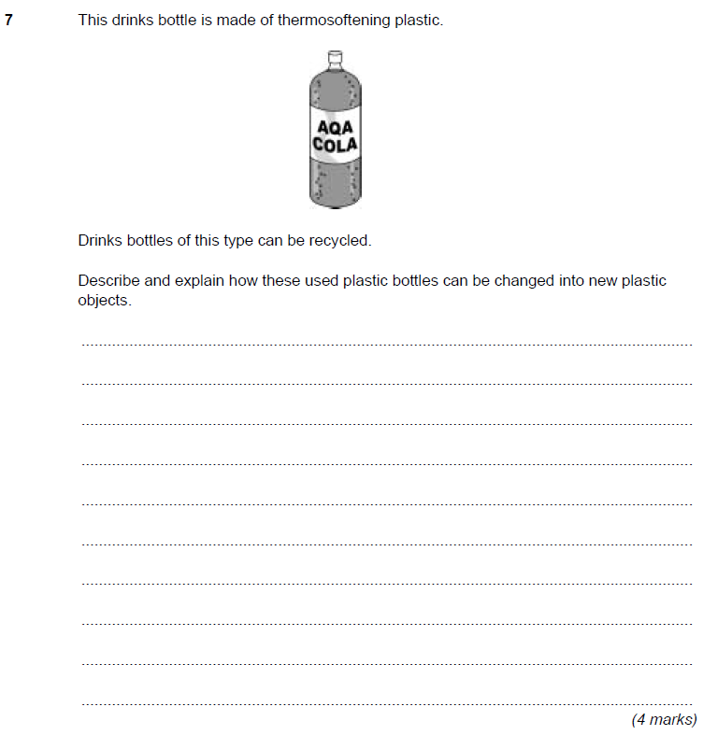
Nanoscience
- Define nanoscience as the study of small particles (1-100nm in size)
- Identify some uses of nanoscience.
- Relate the properties to the fact that they have high surface area to volume ratio.
- Evaluate the development and application of nanoparticles – be able to identify benefits and risks of using nanoparticles.
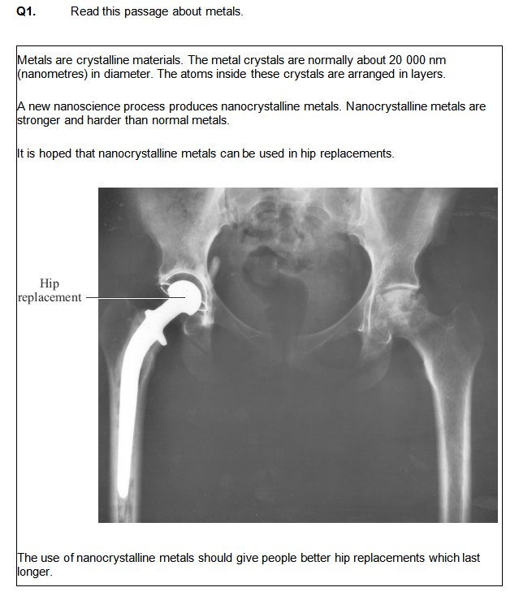
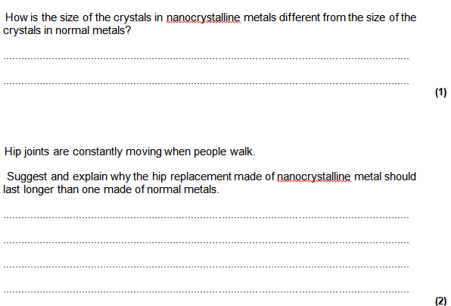
C2.4  Rates and Energy | How Fast?  - Define the ‘rate of reaction’  - Be able to suggest methods for measuring the rate of reaction.  - Name the factors that can affect the rate of reaction.  - Describe collision theory and consider how each factor (temperature, surface area, pressure and concentration) affects the particles in the reaction.  - Know why catalysts are used in chemical reactions and state why new catalysts are being developed.  - Consider the advantages and disadvantages of using catalysts.
Rates of Reactions Questions:
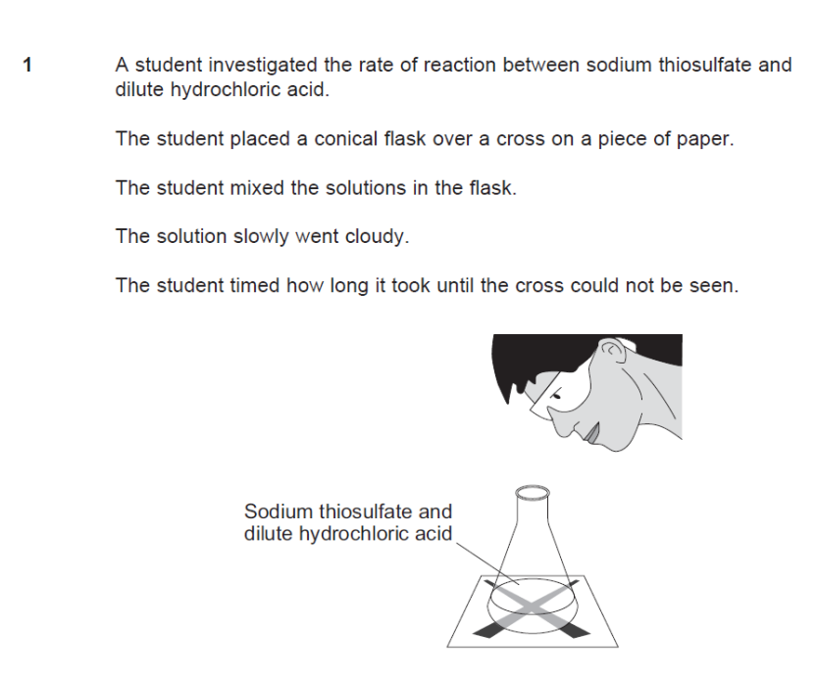
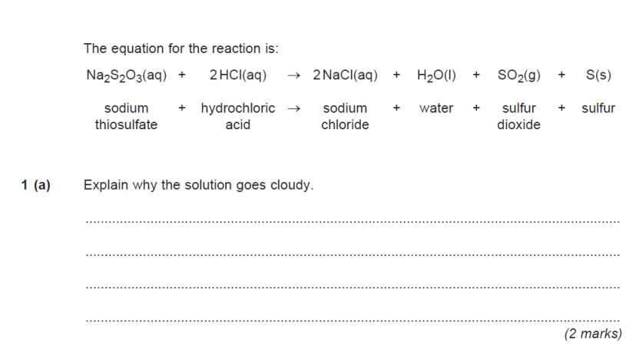
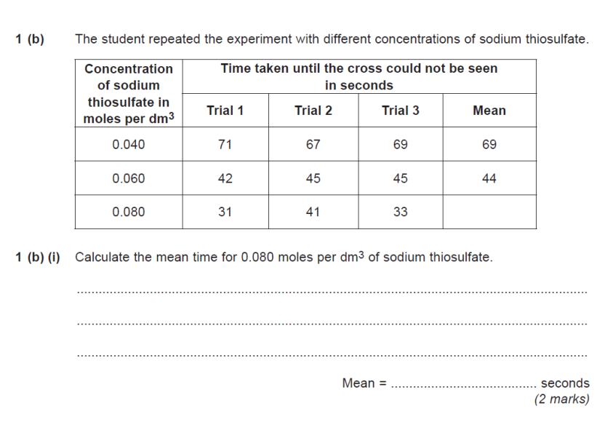
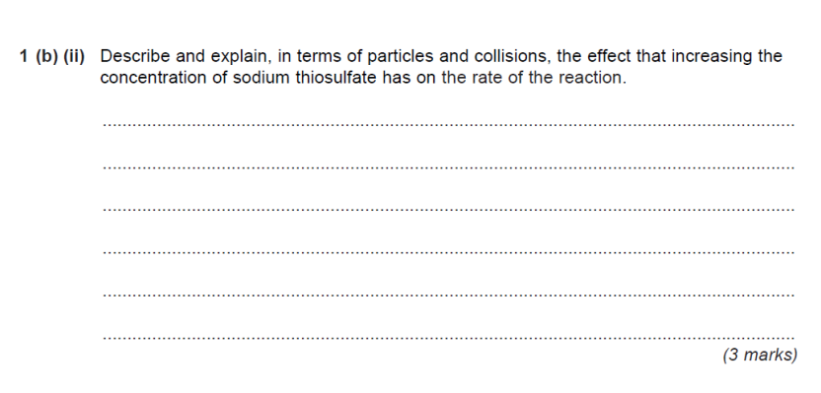
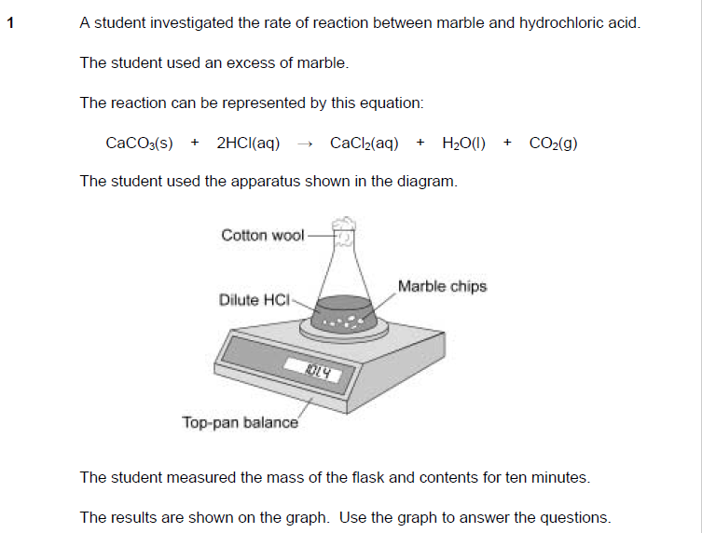

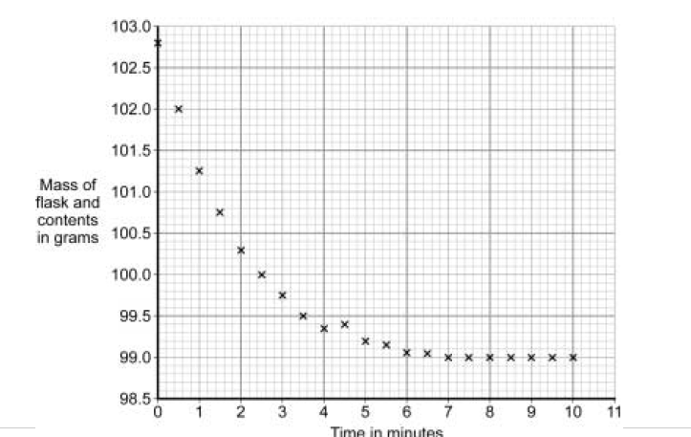

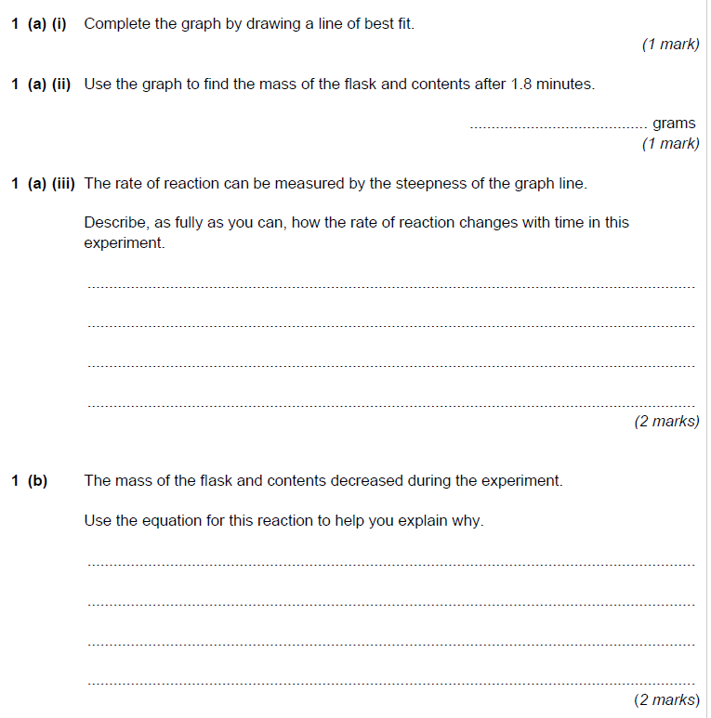
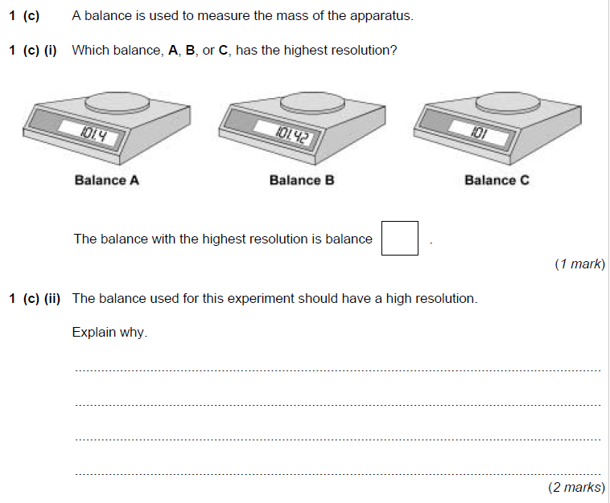
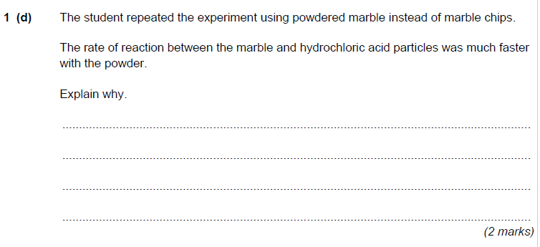

Section |  | Title  - Key Areas to revise | Date revised
C2.4  Rates and Energy |  | Energy  - Recall terms endothermic and exothermic.  - Recognise that in reversible reactions, if it is exothermic in the forwards direction it will be endothermic in the backwards reaction and that the amount of energy released will be identical to the energy absorbed.  - State some examples of uses of both endo and exothermic reactions and evaluate the advantages and disadvantages of using energy changes in chemical reactions.
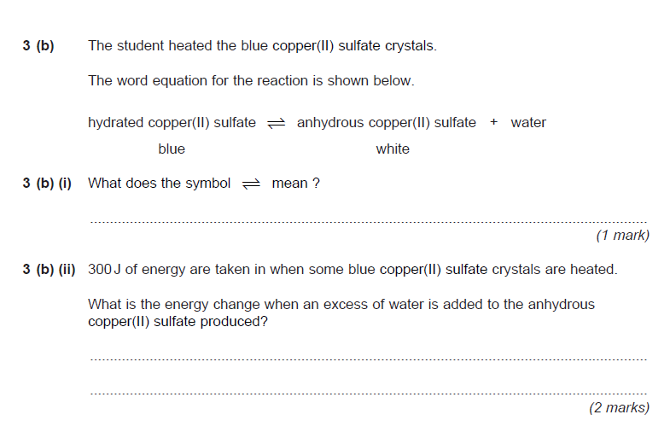
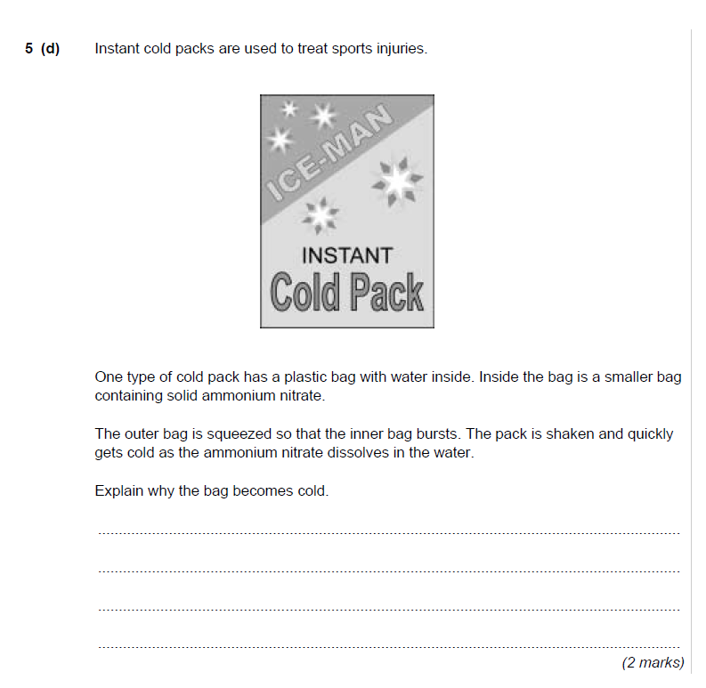
C2.5 Salts and Electrolysis |  | Acids and Alkalis  - Know which ions make solutions acidic and alkaline and that the level of acidity or alkalinity can be measured using the pH scale.  - Define the terms, acid, alkali and base.  - State a definition of neutralisation and be able to write the ionic equation.  - Recall the general word equations for reactions of alkalis, bases and metals with acids.  - Be able to suggest a method for making a named salt (including names of reactants used)  - Define term precipitation and suggest uses for the process.
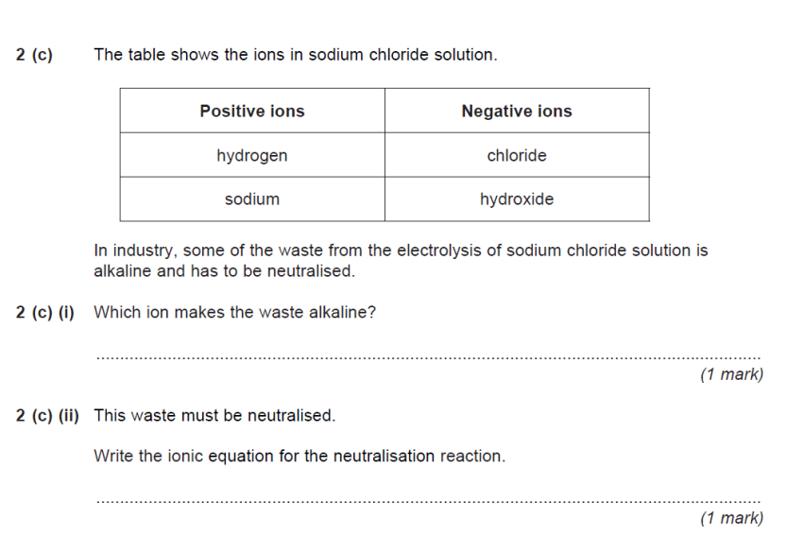

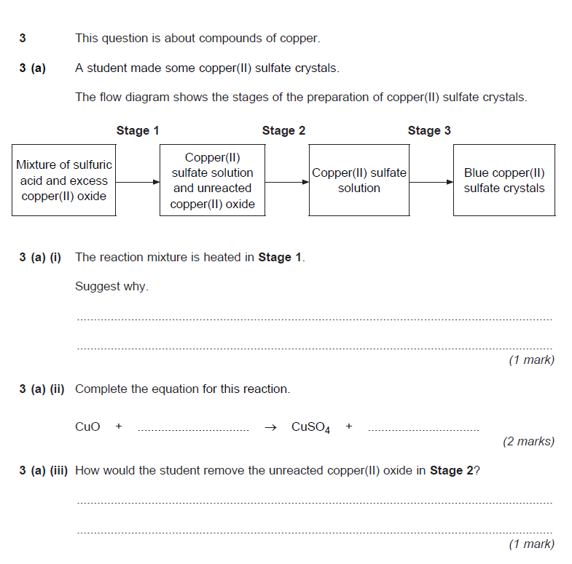
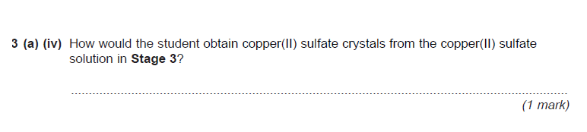
Electrolysis and Electroplating
- Define the term electrolysis
- Predict products from molten electrolysis reactions
- Describe what happens to the ions during electrolysis in terms of movement to oppositely charged electrodes and in terms of reduction and oxidation.
- Know that when substances are dissolved in water that the products of electrolysis may be different.
- In electrolysis of; aluminium oxide and brine be able to describe what happens at each electrode, write half equations, name and suggest uses for the products formed, why is cryolite added to aluminium oxide?
- Define electroplating and give reasons why it is used. Explain the process.
Electrolysis and Electroplating Questions:

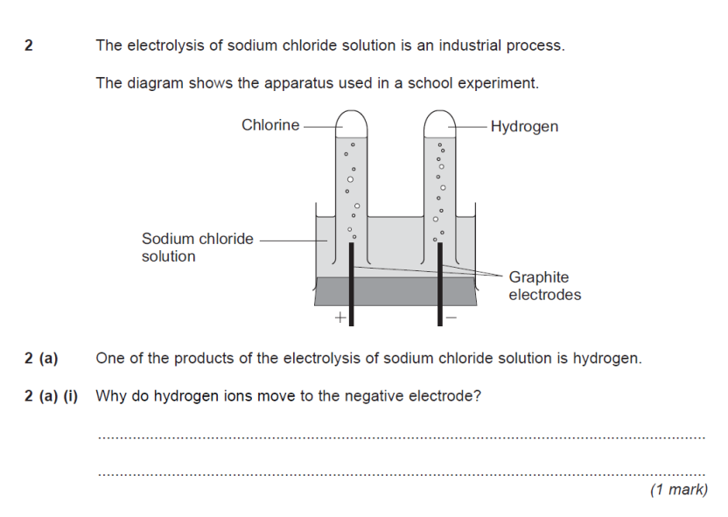
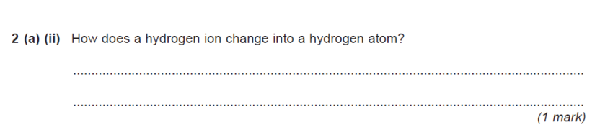
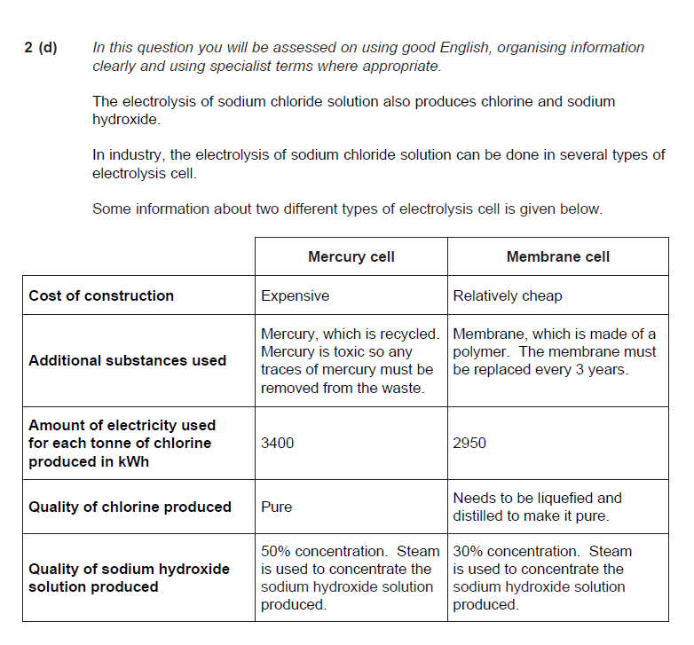
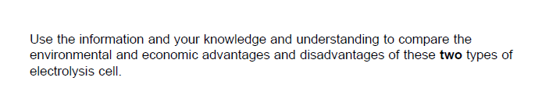
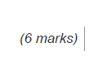
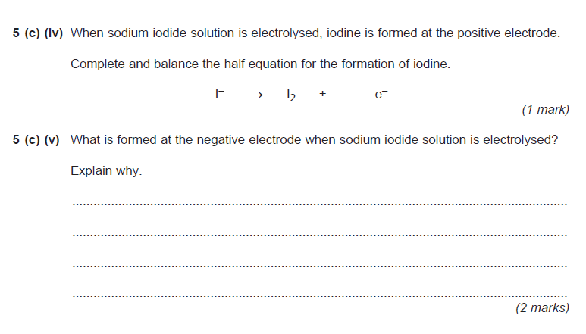
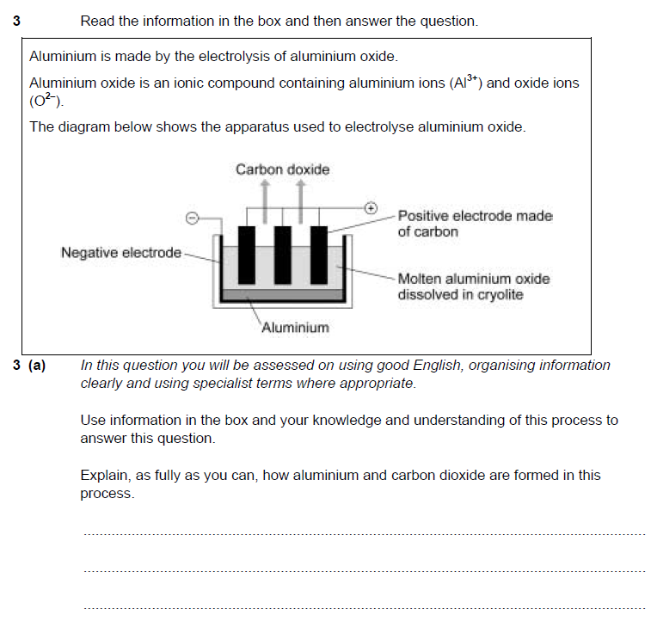

Mark Schemes for Questions

Atomic Structure:

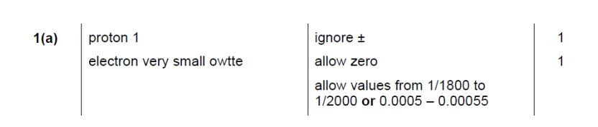
Ionic Bonding:
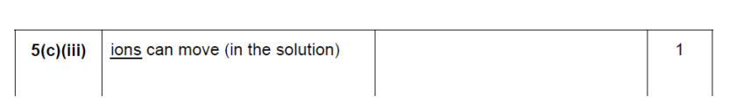
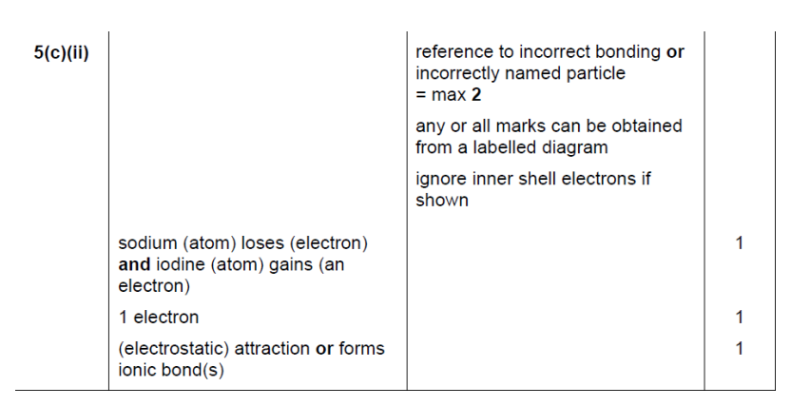
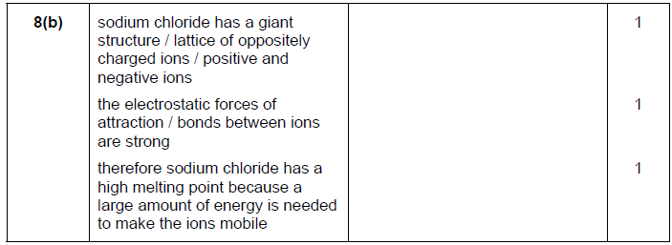

Covalent Bonding:

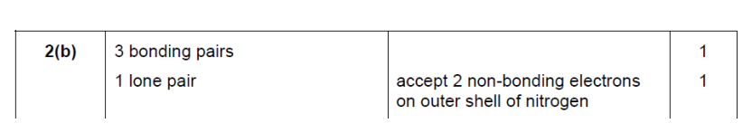
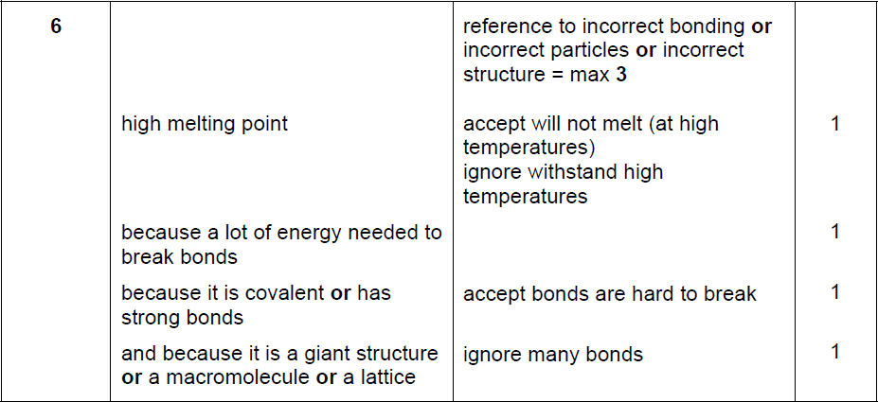

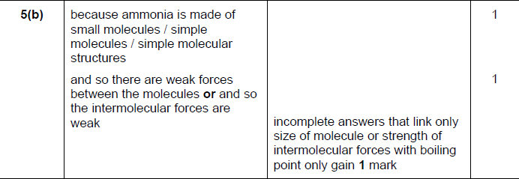
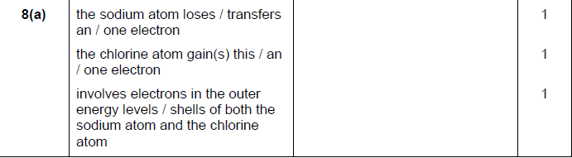

Metals:
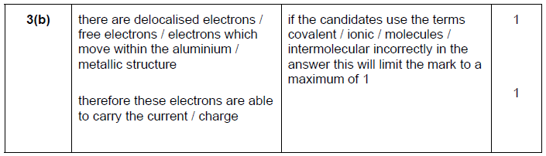
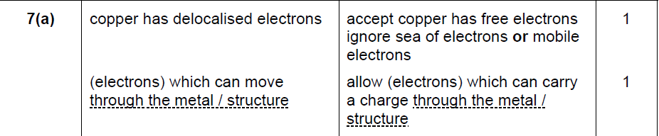
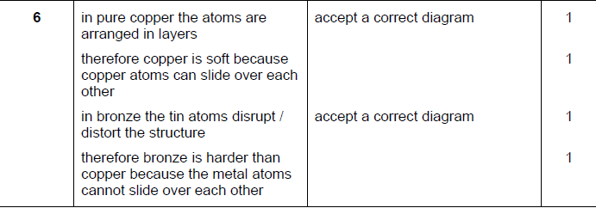
Q2. (a) made of layers
of carbon atoms
weak forces of attraction between layers (owtte) / weak
vertical bonds i.e.
candidate refers to the diagram
layers can slide over each other
layers peel off
each for 1 mark

(b) because there are electrons
which are free (to move)
reason for free electrons / each carbon atom has 3 covalent bonds
each for 1 mark
to max 5

- DIAMOND:
Quality of written communication: All scientific words used correctly
(covalent, bonds, atoms)
1
any two from
• large numbers of covalent bonds
allow giant lattice / structure
• between atoms
do not accept between molecules
• (covalent) bonds strong
accept need much energy to break
2

Polymers:
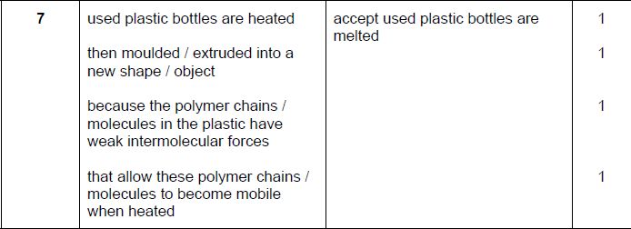
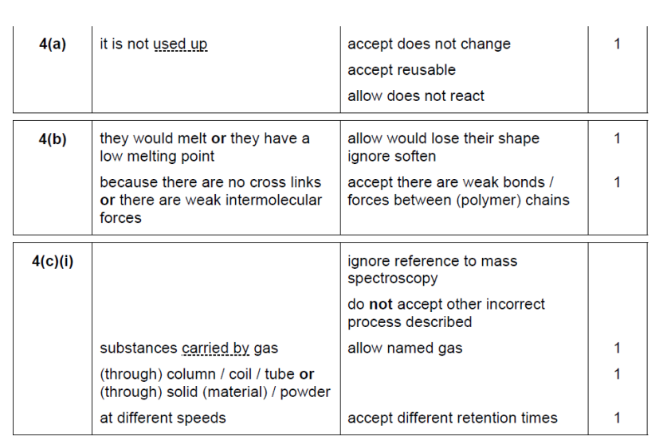

NanoScience:

Q1.
(b) any one from:
• smaller / tiny or very small
do not allow small alone
• correct size range 1 to 100 nanometres
• a few hundred atoms in size
if they state smaller and give a size outside range ignore size if it is less than 20,000
1

(c) harder
1
plus one from:
• so does not wear as quickly / erode as quickly
ignore corrode
• less vulnerable to damage owtte
harder to wear down = 1 mark
• because they have a high surface area to volume ratio
or
stronger (1)
plus one from: (1)
• less likely to break / do not break
accept withstand pressure
• not as vulnerable to damage owtte
harder and stronger alone gains 1 mark
• do not bend out of shape
• because they have a high surface area to volume ratio
1

Rates of reaction:

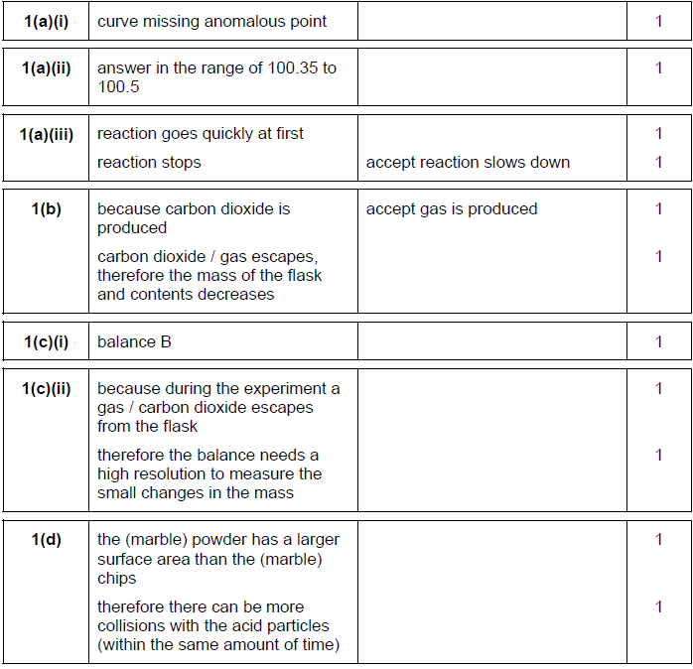
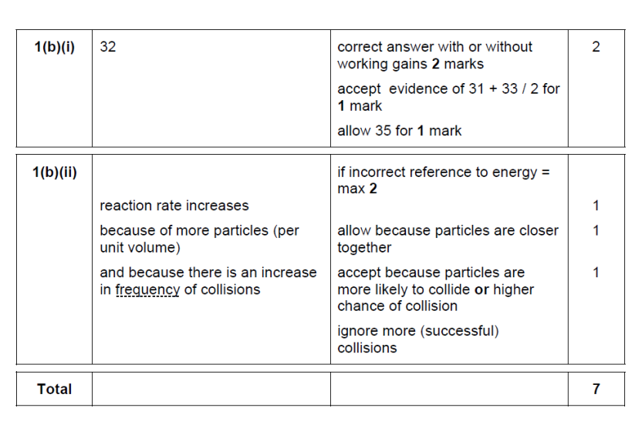
Energy and Reversible Reactions:
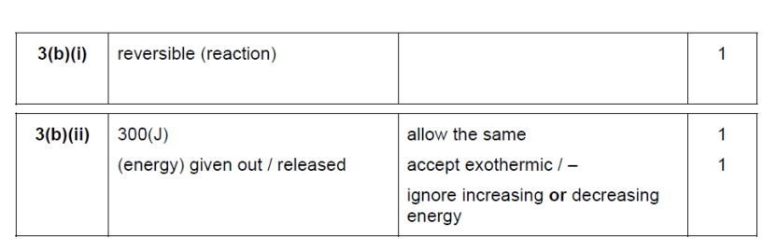
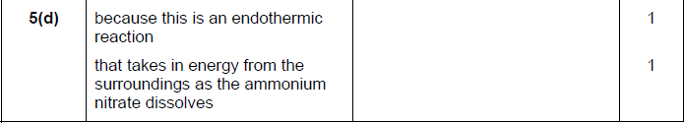

Acids and Alkalis:
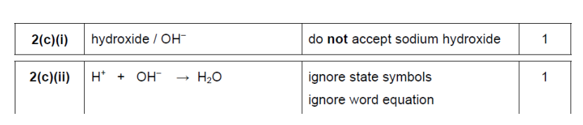
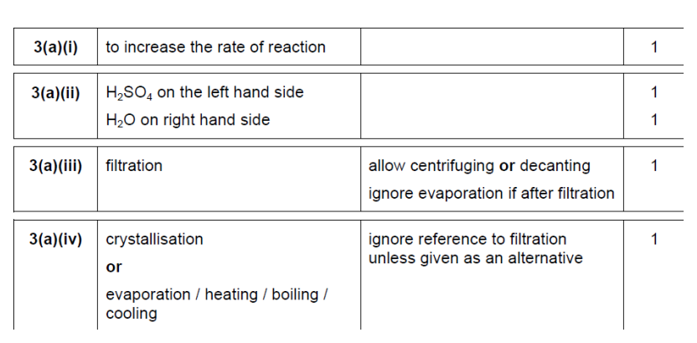

Electrolysis and Electroplating:

